CBC Health Services Hosts Workshop on WaSH in Health Care Facilities
Making available adequate water, sanitation and hygiene (WASH) services in her Health Centers and Hospitals has become top in the list of priorities in the Cameroon Baptist Convention (CBC) Health Services. Reflecting on the 2015 UNICEF and WHO survey of WaSH in 66,101 HCFs spanning 54 countries, the CBC Health Services has seen the need to review WaSH as an organization.

This reflection took place during a workshop on introduction to WaSH in Health Care Facilities from June 19-21, 2019 at the Health Services Complex (HSC) Mutengene with 40 participants. They comprised of the Chiefs of Centers, Nursing Administrators, Medical Doctors, Engineers, and Hospital Administrators. For three days, the participants were drilled on basic concepts of WaSH which were new to almost all of them.

Looking at the UN vision and target by 2030, these Administrators and other Leaders agreed to implement WaSH effectively in their Health Facilities. With the introduction of Antimicrobial Resistance (AMR) which was relatively new, all prescribers at this session (about twenty-four in number) realized how ineffective and inefficient they have been using antibiotics and most especially the abusive nature at which Ceftriaxone, a third cephalosporin is being used in the CBC Health Services. The participants agreed to actively conduct a baseline assessment of WaSH in their health facilities as the starting point. To most of them, WaSH will become a budget head, on the Annual Goals and Budget for the 2020 Financial Year in order to achieve Quality Care that begins with WaSH and Infection Prevention.

Reacting after the presentation on AMR, an MD at the training noted that he felt guilty at the irrational manner in which he has been using most of the medications and pledged to be an advocate among his colleagues who were doing the same if not worse than him.

It should be noted that the CBC Health Services realized the importance of WaSH in HCF when five of her personnel led by Mr. Nkwan Jacob (the then CBC Health Services Infection Prevention and Control Programme Supervisor) led a team of five to Cape Town, South Africa in 2016 to attend a WaSH in HCF training organized by Infection Control African Network (ICAN). The CBC Health Services has, therefore, been a champion and leader of IPC in Cameroon leading in the promotion of clean and safe care and most especially the production and use of alcohol hand rub, the work which has been recognized and is being promoted by many organizations around the world.

The training in Mutengene was led by Kongnyu Emmanuel, the Infection Prevention and WaSH Supervisor of the CBC Health Services. Other key speakers included: Nkwan Jacob, a seasoned Infection Prevention Leader, teacher and a board member of ICAN, Takah Racheal the South West Regional Coordinator of Hygiene and Sanitation.

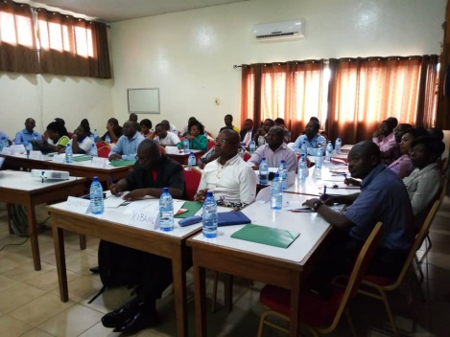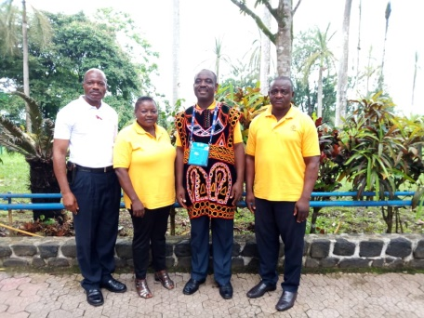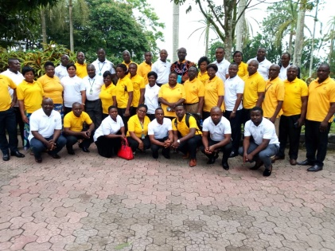
Participants in session Facilitators Group Photo

Kongnyu Emmanuel
IPC & WaSH Supervisor CBCHS

