General WASH in HCF

Resources
- https://www.washinhcf.org/

WASH in Health Care Facilities - Global Baseline Report 2019. (JMP, 2019)

WASH in Health Care Facilities - Practical Steps for Universal Access to Quality Care. (UNICEF & WHO, 2019)
- Water, sanitation and hygiene in health care facilities: Status in low- and middle- income countries and way forward. (UNICEF & WHO, 2015)
- Water, Sanitation and Hygiene in Health Care Facilities Resolution from the 72nd World Health Assembly. (WHO, 2019)

Quotes from UN Leadership:
- "A healthcare facility without WASH is not a healthcare facility." - Dr. Maria Neira, Director of Public Health and Environment, WHO
- "If you can't do the basics, then forget the rest. Prevention, prevention, prevention." - WHO Director-General Dr. Tedros Adhanom Ghebreyesus
- "We must work to prevent the spread of disease. Improved water, sanitation and hygiene in health facilities is critical to this effort.” - UN Secretary-General António Guterres

Data/Statements
- 1 in 4 HCF globally lack basic water services. 1.5 billion people visit HCF without sanitation facilities. (JMP, 2019)
- “WASH in health care facilities (HCF) underpins safe and quality service provision for achieving universal health coverage” (WHO, 2015)
- “To ensure that every health care facility, in every setting, has safely managed, reliable water, sanitation, and hygiene facilities and practices to need staff and patient needs in order to provide quality, safe people-centered care” (WHO, 2015)
- Sustainable Development Goal (SDG) 3, health for all, will not be achieved without water, sanitation and hygiene (WASH) services in health care facilities. (JMP, 2018, p.1)
- Access to affordable, quality health care, good nutrition, and clean water has the ability to save millions of lives of mothers and children. We know that high standards of sanitation in health care facilities contributes to low newborn mortality rates. (UNICEF, 2018, pg.1 and 13)
- Effective hygiene practices, clean health care facilities and equipment, as well as IPC practices make up the building blocks of WASH in health care facilities. (WHO, 2017)
- “Effective infection prevention and control (IPC) and water, sanitation and hygiene (WASH) are critical to stopping the spread of antibiotic-resistant organisms.” WHO’s AMR Global Action Plan includes improving IPC and WASH as one of its five objectives. (WHO, 2017)
- “Adequate and resilient WASH services in health care facilities are essential for outbreak prevention, preparedness and control (e.g. Cholera, Ebola).” (WHO, 2015)

Maternal, Newborn and Child Health (MNCH)
Resources:
- EVERY CHILD ALIVE: The urgent need to end newborn deaths. (UNICEF, 2018)
- The UNICEF Health Systems Strengthening Approach. (UNICEF, 2016)
- EVERY NEWBORN: An Action Plan to End Preventable Deaths. (WHO, 2014)
- Network for Improving Quality of Care for Maternal, Newborn and Child Health (WHO)
- Every Mother Every Child Campaign (UNICEF)

Data/Statements:
- “It is estimated that one in five births globally take place in Least Developed Countries (LDCs), and that, each year, 17 million women in these countries give birth in health care facilities with inadequate water, sanitation and hygiene.” (JMP, 2019, pg. 77).
- An estimated 7,000 newborns die globally every day. More than 80% of these deaths can be prevented with basic solutions, such as clean water; antenatal and postnatal nutrition; and access to a well-trained workforce. (UNICEF, 2018, pg.5)
- In 2015, approximately 300,000 women died during pregnancy and delivery due to inadequate health care services, nutrition, water and sanitation, and education. (UNICEF, 2016 pg. 42)
- “Saving lives is never simple, and no single government or institution, acting alone, will meet the challenge of ending preventable newborn deaths. Indeed providing affordable, quality health care for every mother and baby, starting with the most vulnerable, will require: … Guaranteeing clean, functional health facilities equipped with water, soap and electricity within reach of every mother and baby…” (UNICEF, 2018, pg.2)
- “Without even the most basic standards of hygiene, mothers and babies are at risk of disease and infection.” (UNICEF, 2018, pg.21)
- The lack of clean water, sanitation, and handwashing soap comprises the ability to provide basic maternal, newborn and child health that control and prevent infections. (UNICEF & WHO, 2015, pg.IV)
- The “six cleans” required for a safe delivery are: 1. Clean hands of the attendant 2. Clean surface 3. Clean blade 4. Clean cord tie 5. Clean towels to dry the baby and then wrap the baby 6. Clean cloth to wrap the mother. (WHO, pg. 73)

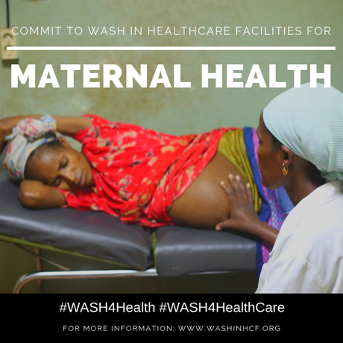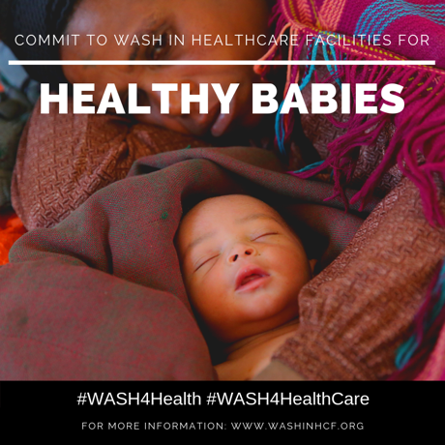

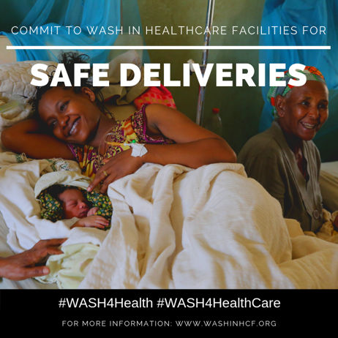

Infection Prevention and Control (IPC) and Patient Safety
Resources:
- Guidelines on core components of infection prevention and control programs at the national and acute health care facility level. (WHO, 2016)
- Improving Infection Prevention and Control at the Health Facility: Interim practical manual supporting implementation of WHO Guidelines on Core Components of Infection Prevention and Control Programmes. (WHO, 2018)
- Interim Practical Manual supporting national implementation of the WHO Guidelines on Core Components of Infection Prevention and Control Programmes. (WHO, 2017)
- WASH in health care facilities: Joint action for universal access and improved quality of care. (WHO, 2015)
- WHO Guidelines on Hand Hygiene in Health Care: a Summary. (WHO, 2009)
- Clean Hands Save Lives Campaign. (WHO)
- Your 5 Moments for Hand Hygiene. (WHO)

Data/Statements:
- Safe WASH in health care facilities is critical in IPC to protect patients, health workers, including cleaning staff and other staff, and communities from avoidable infections.
- “On average, 1 in every 10 patients is affected by healthcare-associated infections (HAIs) worldwide. In acute care hospitals, out of every 100 patients, 7 in developed and 15 in developing countries will acquire at least one HAI.” (WHO, 2016, pg. 6)
- “Effective infection prevention and control (IPC) is a key determinant of the quality of health service delivery to achieve people-centered, integrated universal health coverage” (WHO, 2016, p.20)
- For IPC programs to be successful in health care facilities, adequate supplies including innovative equipment, functioning WASH services, and clean and hygienic environments are necessary. ” (WHO, 2016, p.30)
- The lack of WASH and infection prevention and control practices in health care facilities increase the risk of acquiring and spreading health care-associated infections that may become resistant to treatment. (WHO & UNICEF, 2016)
- A simple way to reduce health care-associated infections and dramatically enhance patient safety is to regularly practice good hand hygiene. (WHO, 2009, pg.I)

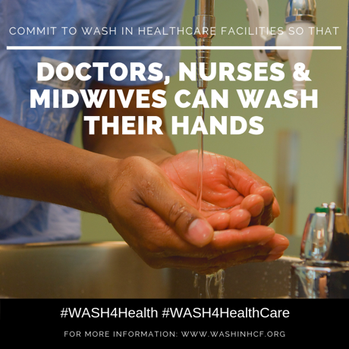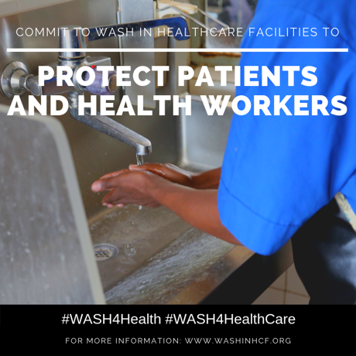

Antimicrobial Resistance (AMR) and Global Health Security (GHS)
Resources:
- IPC poster for World Antibiotic Awareness Week. (WHO, 2017)
- Hand hygiene and AMR policy briefing note. (WHO & UNICEF, 2016)
- Global Action Plan on Antimicrobial Resistance. (WHO, 2015)
- The AMR Challenge. (CDC)
- Advancing global health security from commitments to actions. (WHO, 2016)

Data/Statements:

- “Good sanitation, hygiene and other infection prevention measures that can slow the development and restrict the spread of difficult-to-treat antibiotic-resistant infections are a ‘best buy.’” (WHO, 2015, p. 5)
- Universal access to WASH has the ability to reduce diarrhea cases by 60%. (WHO & UNICEF, 2016)
- Poor WASH in health care facilities can result in expensive, hard-to-treat infections. (WHO & UNICEF, 2016)
- Antibiotic resistant infections have a greater risk of spreading if hospital hygiene and infection prevention and control measures are inadequate. (WHO, 2015, p. 3)
- Lack of basic social services, poor nutrition, and insufficient access to water and sanitation, along with poor medical care increases the risk of infectious diseases. (WHO, 2016 pg.9)
- Primary health care facilities in rural areas are critical in mitigating the spread of disease, as seen during Ebola and cholera outbreaks. Without WASH services in health care facilities, health care workers would not be able to successfully prevent and control outbreaks. (UNICEF & WHO, 2015, pg.IV)

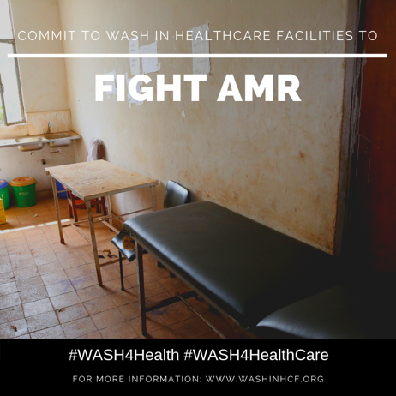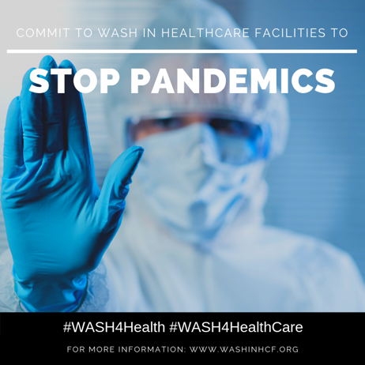

Quality of Care
Resources:
- Standards for Improving Quality of Maternal and Newborn Care in Health Facilities. (WHO, 2016)
- Network for Improving Quality of Care for Maternal, Newborn and Child Health (WHO)
- WASH’s role in Health Care Facilities to achieve Universal Health Coverage. (WHO, 2015)

Data/Statements:
- Safe, quality health care cannot be provided in health care facilities without sustainable water, sanitation and hygiene services. (JMP, 2018 p.vii)
- Effective IPC practices, coupled with WASH services provided at the time of birth, have the ability to improve health outcomes. (JMP, 2018 p.1)
- “WASH in health care facility standards should be established and enforced, placing people at the center, to improve quality of care.” (WHO, 2015)

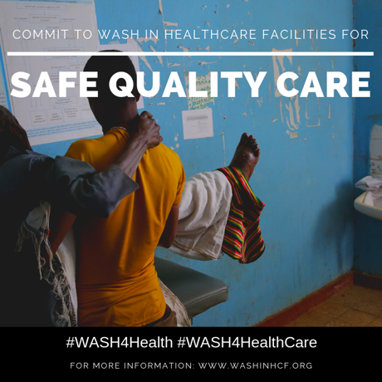

Universal Health Coverage (UHC) and Health System Strengthening (HSS)
Resources:
- Achieving Quality Universal Health Coverage Through Better Water, Sanitation and Hygiene Services in Health Care Facilities: A Focus on Ethiopia. (WHO, 2017)
- The UNICEF Health Systems Strengthening Approach. (UNICEF, 2016)
- WASH’s role in Health Care Facilities to achieve Universal Health Coverage. (WHO, 2015)

Data/Statements:
- Definition of Universal Health Coverage “is defined as ensuring that all people can use promotive, preventative, curative, rehabilitative, and palliative health services they need, of sufficient quality to be effective, while also ensuring that the use of these services does not expose the user to the financial hardships”. (WHO, 2015)
- “The terms ‘universal’ and ‘for all’ in Sustainable Development Goal Targets 6.1 and 6.2 highlight the need for expanding WASH monitoring beyond the household to include non-household settings, such as health care facilities and schools.” (JMP, 2018 p.1)
  - Similarly stated in (WHO, 2017 pg.8)
- Achieving UHC will require a focus on much more than health systems, including clean energy and safe water systems in health care facilities. (UNICEF, 2016 pg. 45)
- Stronger linkages between health, nutrition, WASH, and HIV prevention are necessary for UNICEF to assist in building robust, responsive, and resilient health systems.“ (UNICEF, 2016, pg.2)

