UNICEF Venezuela: Case study on the use of innovative approaches to enable safe water, hand hygiene and other IPC practices
A path for scaling-up technology, capacities and solutions
Different type electric chlorinators were installed in targeted health care facilities in response to Covid19. A total of 35 electrolytic chlorinators were installed in 35 Hospitals across the country during 2020/21.
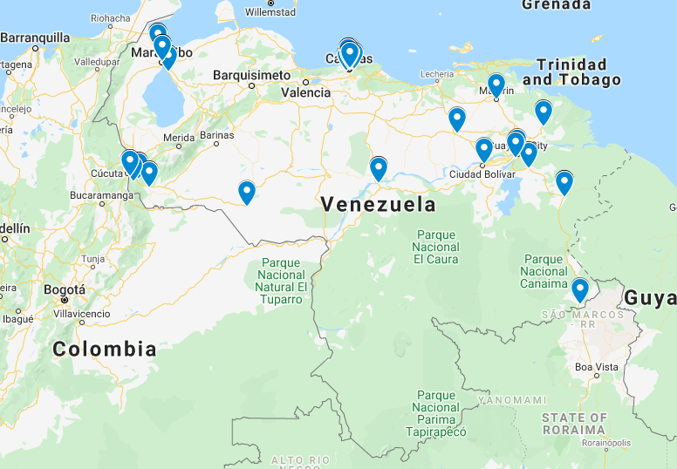
- The machine allows the production of 4 liters of CL for 1KG of table salt, which is used for disinfestation of water and cleaning surfaces
- Patients and surrounding communities were engaged to understand their needs for the product
- Communities provide salt to hospitals, and also exchange salt with other commodities (soap and hand sanitizer)
- Win-win situation for both communities and HCFs
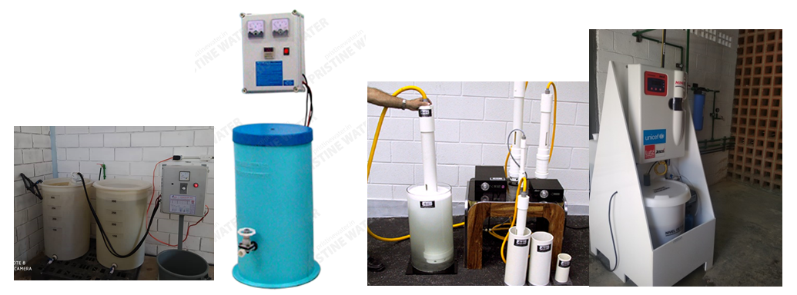
Brand/model: | Suinca Suinchlor-6000 | Pristine PBP-100 | Aquachlor AC-100 | Lutz-Jesco MiniChlorgen 90 | Suinca Suinchlor-200
Type: | Manual / Batch | Manual / Batch | Manual / Batch | Automatic | Manual / Batch / Solar
Power: | n.d. | 0.63 kWh, 110-240 VAC | 0.75 kWh, 110-240 VAC | 0.60 kWh, 110-240 VAC | 12 V
Chlorine capacity: | 125 g/h | 125 g/h | 110 g/h | 90 g/h | 50 g/h
Chlorine conc.: | 6 g/L | 7-8 g/L | 6 g/L | 6 g/L | 5 g/L
Salt consumption: | 0.4 Kg/h | 1.1 Kg/h | 0.5 Kg/h | 0.3 Kg/h | 0.3 Kg/h
Author
David Simon
Co-authors
- Pedro Ogando dos Santos (WASH specialist) pogando@unicef.org
- Dr. Ana Cristina Guillen (WASH-IPC officer) aguillen@unicef.org
- David Simon (Chief WASH) dsimon@unicef.org

