HAND HYGIENE AND THE MULTIMODAL APPROACH GROUP WORK

Instructions

In your group, together read through the scenario below.
__________________________________________________________________
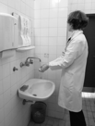
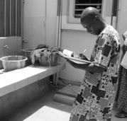
- Over the last few months, in a local clinic, each staff member has attended a training workshop on hand hygiene, focused mainly on how to clean hands (the technique).
- To ensure that everyone is aware of the importance of hand hygiene, posters of the correct technique have been placed on the walls of the clinic, usually near hand wash basins.
- You have been asked to perform hand hygiene audits. Hospital management have also been asked to participate but have said no.
- Your audit results highlight that staff are not cleaning hands before touching patients. You place a paper copy of the results on the clinic manager’s desk, but they do not seem interested. You try to schedule a meeting but get no response.

- Today you hear that a female patient in the clinic is anxious as her newborn baby has a fever and she is very worried that staff have not been cleaning their hands before they touch baby. She is aware from family members that poor hygiene can cause infections in babies.

Discuss the following in your groups
- Do you think anything is lacking in the current approach to hand hygiene improvement?
- What do you think could be done differently?
- Can you think of any examples you have seen that might be useful in achieving a multimodal approach to clean hands at the right times?

