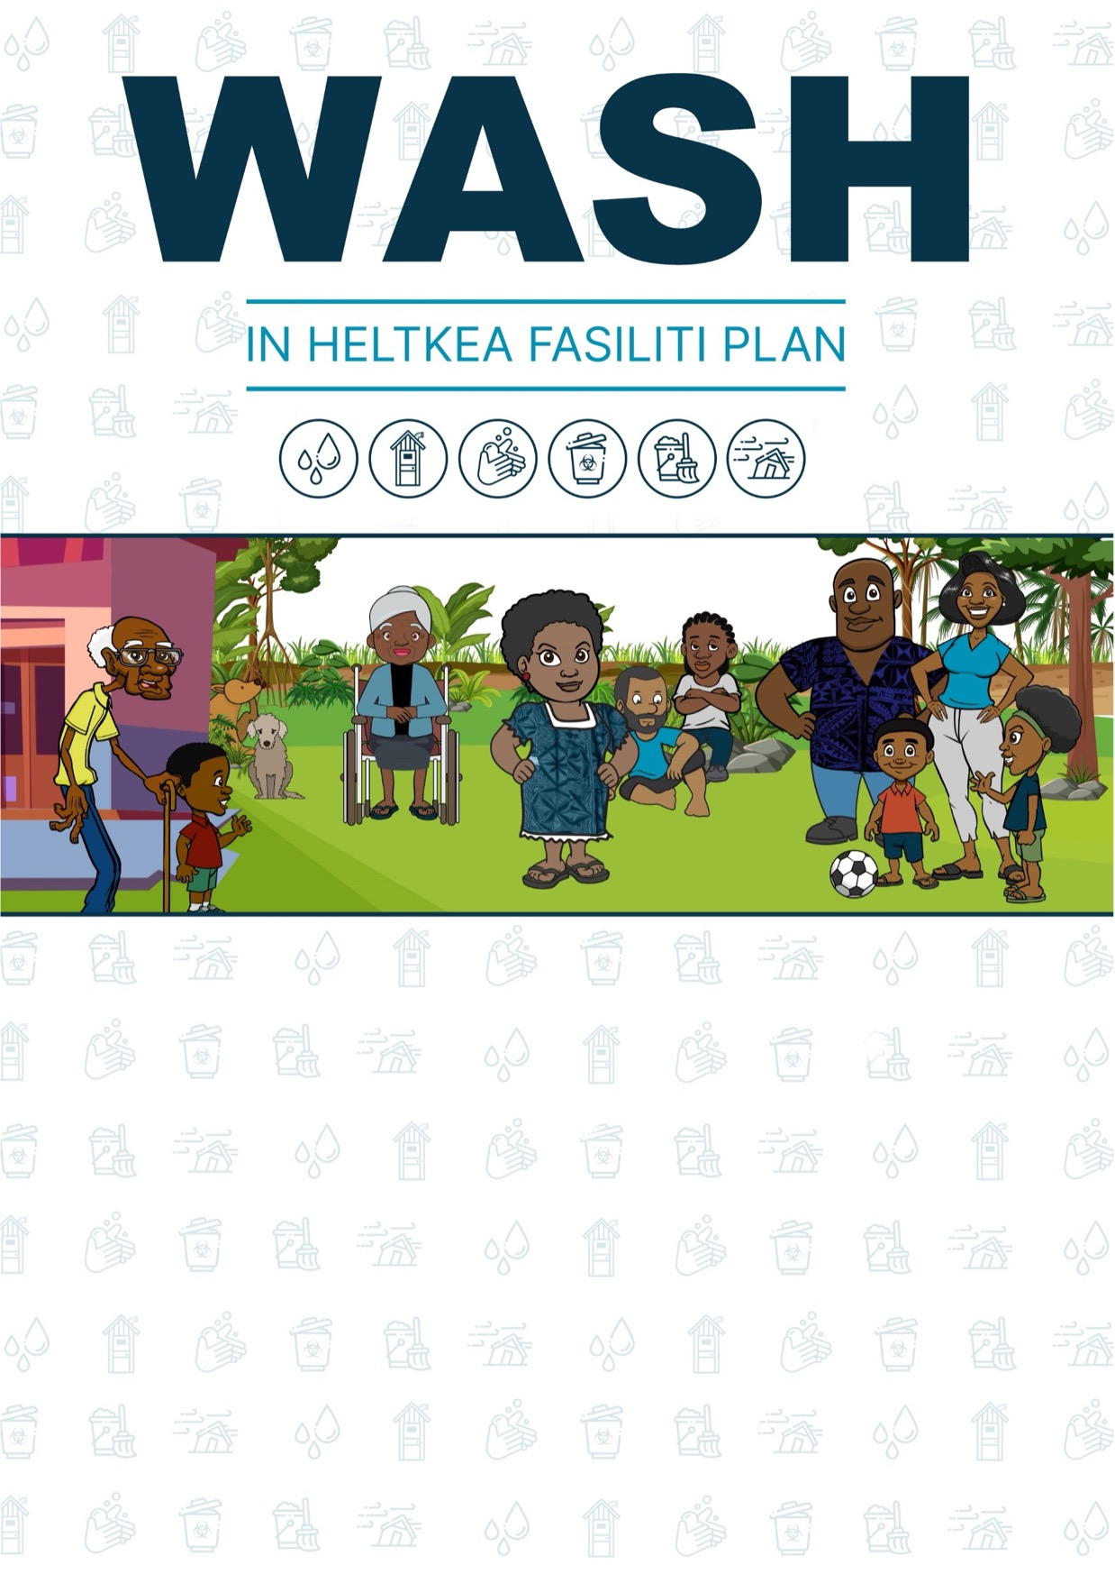

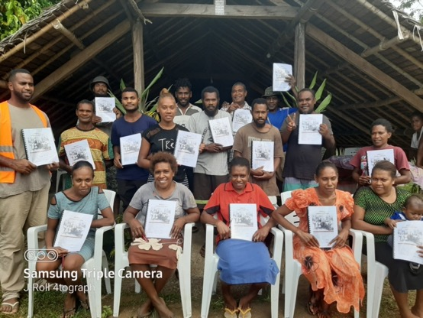
ADEM WAN FOTO BLONG OL PATISIPEN IA
ENTA

Ol infomesen blong Heltkea Fasiliti (HKF)
Nem blong Heltkea Fasiliti:
Wanem kaen Fasiliti: |  | Aid Pos |  | Dispenseri |  | Helt Senta |  | Hospitol
Eria Kaonsel / Aelan
Deit blong asesmen ia: |  |  |  | kasem:
Populesen we i usum HKF:
Hamas haoshol i stap usum Heltkea Fasiliti:
Fasiliti kontak: |  |  |  | Fon:
Nem blong Fasiliteita:
Hu ia fandem woksop ia: |  |  |  | Ripot i kam long:

WASH Plan Samari Infomesen
Not: Fulumap pej ia long en blong woksop, bae yumi kaontem ol risal mo fulumap ol bokis andanit. Pej ia i holem ol samari infomesen blong asesmen, impruvmen mo ol aksen we hemi impoten tumas. Sapos yumi no faenemaot eni Problem long wan eria, yumi save talem olsem yumi mitim “Mitim Standed”.
Long en, bae yu stikim pej ia long wan wol long fasiliti we yu save stap luk oltaem blong rimaendem evriwan long ol wok we i stap blong mekem.

Seksen 4: Impruvmen Plan
Kaontem ol ansa long Seksen 4 hamas impruvmen i nidim long ol difren Katagori.
 | 1. ISI/JIP & LO RISK | 2. ISI/JIP & HAE RISK | 3. HAD/SAS & LO RISK | 4. HAD/SAS & HAE RISK
Wota
Saniteisen
Haejin
Toti
Fasiliti Kondisen
Disasta Redines
FULMAK =
Seksen 5 – Jekemap mo Fiksimap: Raetem trifala top aktiviti blong mekem.
Aksen blong mekem | Hu bae i mekem? | Wanem taem? Hamas taem?

Seksen 6 – Komiti Aksen:
Disaed long deit blong nekis miting mo raetem andanit:
Deit blong nekis miting blong Helt Komiti:
Deit blong nekis WASH Plan asesmen:

Ol pej blong dokumen ia:

Konten:
Helti Komuniti tru long gudfala Heltkea | ……………………….. | p. 4
Introdaksen long WASH in Heltkea Fasilitis | ……………………….. | p. 5
Ol wok blong Plan | ……………………….. | p. 6
Heltkea Fasiliti blong Evriwan | ……………………….. | p. 7
SEKSEN 1: Mekem wan Tim | ……………………….. | p. 8
SEKSEN 2: Diskribsen blong Fasiliti | ……………………….. | p. 9
SEKSEN 3: Fasiliti Asesmen | ……………………….. | p. 14
SEKSEN 4: Impruvement Plan | ……………………….. | p. 35
SEKSEN 5: Jekemap mo Fiksimap | ……………………….. | p. 53
SEKSEN 6: Helt Komiti Aksen | ……………………….. | p. 56
EVALUESEN FOM | ……………………….. | p. 58
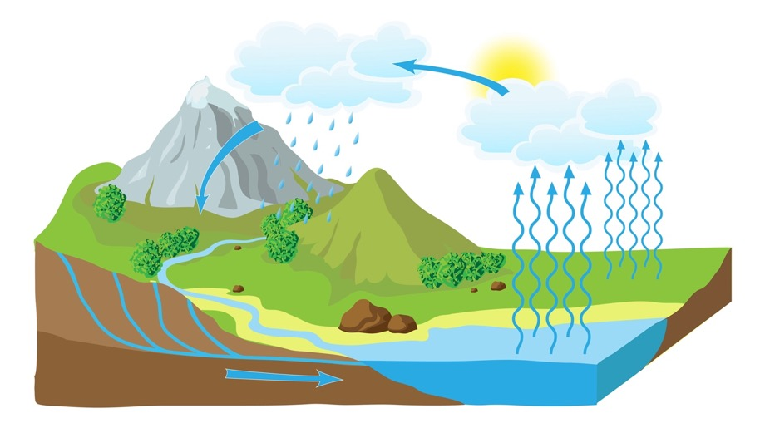

Helti Komuniti tru long gudfala Heltkea
Welkam long WASH insaed Heltkea Fasiliti Plan blong Fasiliti ia. Ol Heltkea Fasiliti blong yumi long Vanuatu hemi men ples we komuniti i save kam taem we oli gat siknes or kil.
Yumi mas mekem sua se ol sikwoman, sikman mo staf oli stap sef taem we oli kam long Fasiliti ia.
Taem we yumi lukaotem gud long ol seves we Helt Fasiliti i givimaot, inogat man bae fraet blong kam lukim nes.

From wanem WASH hemi impoten?
WASH hemi wan toktok we oli mekem hem sot aot long Wota, Saniteisen mo Haejin. Hemia nao ol topik we hemi impoten tumas blong lukaotem gud long wan Heltkea Fasiliti.
Wota  - Risos blong wol we yumi stap usum evridei long laef.  - Wota save spoilem helt blong yumi tu sapos yumi no lukaotem gud. | Saniteisen  - Ol smolhaos mo ples blong holem ol Toti blong man (faeces).  - Mas mekem sua i gat inaf gudfala toilet long komuniti. | Haejin  - Ol fasin mo ples blong wasem han blong blokem ol kaen sik.  - Awenes blong ol gudfala fasin blong haejin long komuniti.

Tri narafala topik we yumi mas lukaotem long wan Heltkea Fasiliti hemi:
Toti  - Ol fasin mo fasiliti blong kolektem ol difren kaen rabis.  - Fasion blong lukaotem ol kaen rabis we hemi save kosem kil bakegen. | Kondisen  - Olsem wanm yumi stap lukaotem bilding mo yard blong Fasiliti blong kipim hem i klin mo sef blong evriwan long fasiliti. | DisastA  - Ol aksen we yumi mas mekem bifo, during, mo afta long wan disasta.  - Mekem sua se ol komuniti mo staf oli pripea gud.

Introduksen long WASH insaed Heltkea Fasiliti Plan
Dokumen ia hemi wan gaed blong mekem asesmen mo givem gudfala tingting long saed blong Wota, Sanetesem, Haejin (WASH). Mo tu hemi kavremap ol Medikol Toti, Kondisen blong Fasiliti, mo Disasta.
Blong fulumap ol ansa long Plan ia, bae yumi wok long ol inspeksen mo asesment truaot long minimum blong 3 dei, kasem 4 dei sapos hemi wan Hospital. Yumi mas gat ol toktok blong ol helt woka, mo ol woman mo man blong komuniti we oli save gud ol samting blong ol sistem blong Fasiliti.

Risal blong woksop mo Plan we yumi wantem long en hemi:
“Fasiliti and MoH i gat wan gudfala ripot we hemi talemaot olsem wanem Fasiliti I stap wok naoia long saed blong Wota, Sanitesen, Haejin, Toti, Kondisen blong Fasiliti mo Disasta. Helt Komiti oli gat komitimen mo save long olsem wanem blong mekem impruvmen long Fasiliti we i nidim”.
Long Plan ia i gat Siks Seksen blong fulumap. Ol Seksen i stap folem wan sekol from yumi save ripitem ol step ia taem we i gat sam jenis long Fasiliti o wan yia i pas. Komiti sud mekem riviu evri yia.

3A – Wota
3B – Saniteisen
3C – Haejin
3D – Toti
3E – Kondisen blong Fasiliti
3F – Disasta
HELTKEA FASILITI WASH PLAN
WASH in HKF fremwok ia i kamaot long ‘Drinking Water Safety and Security Plan’ (DWSSP) fremwok we Dipatemen blong Wota Risos (DoWR) blong ol wota supplae blong komuniti. The HCF WASH Plan hemi inkludem moa samting long saed long Healthcare Fasiliti mo hemi stap folem ol toktok long WHO/UNICEF ‘Joint Monitoring Programme’ (JMP) mo ‘WASHFIT Tool’.

Ol wok blong Plan

*Evri taem yumi brek blong kaekae evri wan mas wasem han long wan bigfala grup*
Blong ronem woksop ia i sud gat two staf or representativ blong Ministri blong Helt (MoH) i stap fasiliteitem. Long evi Seksen yumi wantem achievem wan Risal we hemi stap andanit. Bae yu lukluk lon ol Risal mo fom we hemi stap insaed long Tulkit buklet tu.
SEKSEN 1: | MEKEM WAN TIM | Taem: | Fes dei long moning
Risal: | - Raetem ol nem blong ol tim memba we long kos ia.  - Mekem agrimen blong wok had mo representem ful komuniti.
Wanem i nidim: | Pen, Tim rejestresen Fom (nekis pej)
SEKSEN 2: | DISKRIBSEN BLONG FASILITI | Taem: | Haf dei
Risal: | - Mekem wan map mo raetem ol impoten infomesen blong Fasiliti long saed blong Wota, Saniteisen, Haejin, Toti, Kondisen blong Fasiliti mo Disasta.
Wanem i nidim: | Kalakala pen, flipchat, GPS blong rikodem Latitud mo Longitud
SEKSEN 3: | ASESMEN + RIK MANEJMEN | Taem: | Wan ful dei
Risal: | - Wokbaot blong lukluk mo mekem asesmen long Fasiliti long saed blong blong Wota, Saniteisen, Haejin, Toti, Kondisen blong Fasiliti mo Disasta.  - Faenemaot ol Problem we hemi stap mo wanem Asksen i nidim blong daonem Risk.
Wanem i nidim: | Pens, Flo-ret pepa, Renwota paep, CBT Test gaed, Ris Asesmen Kwestin blong Sanitesen mo Wota Sistem.
SEKSEN 4: | IMPRUVMEN PLAN | Taem: | Haf dei
Risal: | - Stori mo disaed long ol impruvmen i nidim long Fasiliti ia blong daonem namba blong ol Problem yumi faenemaot.  - Mekem ol kosting blong impruvmen mo putum deit blong finisim wok.
Wanem i nidim: | Pens, flipchat, ol “Bill of Quantities” templet fom.
SEKSEN 5: | JEKEMAP MO FIKSIMAP | Taem: | Haf dei
Risal: | - Disaed long long ol aktiviti we I nid blong Jekem mo Fiksim ol impoten samting blong Fasiliti.
Wanem i nidim: | Pens, flipjats, Red Kros O&M Manual
SEKSEN 6: | KOMITI AKSEN | Taem: | Aftanun sesen
Risal: | - Disaed long ol aksen we Helt Komiti bae mekem long wan yia mo setemap wan deit blong ol miting mo rivyu long WASH Plan ia.
Wanem i nidim: | Pen, flipchat, komitmen blong WASH insaed HCF tim.

Wan Heltkea Fasiliti blong evriwan
“Mas gat ol kaen blong mekem Wol i wok!”
Olsem wan pasel, ol komuniti blong yumi I gat ol difren kaen pipol: man, mama, gel, boe, olfala, yangfala, pipol wetem disabiliti mo ol aktiv wan. Blong leftemap komuniti, ol Heltkea Fasiliti mas mekem sua se ol memba blong komuniti i gat ikwel akses long Heltkea.

EKSASAES – Wokboat long sus blong mi
Naoia bae yumi talem wan stori blong fo pipol blong komuniti we oli mas mekem wan trip igo long Heltkea Fasiliti blong karem meresin. Eksasaes ia bae soem ol jalenj we difren pipol i stap fesem long difren situesen taem we oli go long wan Heltkea Fasiliti.
- Jusum fo volontia aot long grup blong represen ol difren grup blong komuniti andanit:
 | a. | Woman we hemi no save wokbaot gud |  | b. | Woman we hemi nogat disabiliti |  |  | c. | Man we hemi no save lukluk gud |  | d. | Man we hemi nogat disabiliti
- Ol volontia oli go stanap long wan saed long rum. Mekem sua i gat inaf spes long fored.
- Long evri step blong Journey, evri volontia mo ol tim memba mas disaed se step ia hemi:
 |  |  | ISI  Sapos Yes: Tekem tri step fowod |  |  |  |  | JALENJ  Tekem wan step |  |  |  |  | NO SAVE MEKEM  Stap nomo

Wokbaot:
- Long moning yu wekap mo yu gat wan fiva we hemi strong tumas mo yu mas lukim Nes. Hemi wan skul dei mo tufala pikinini blong yu oli no dring ti yet.
- Blong wokboat i go long rod blong Trak hemi tekem 10 minit, mo yu mas klaem long Trak.
- Taem we yuk kam long Heltkea Fasiliti, yu luk wan set blong step we yu mas klaem blong go insaed.
- Afta yu we yu bin wet long Nes smoltaem, yu mas go long toilet. I gat wan insaed long Fasiliti be entry blong hem hemi smol mo doa hemi brokbrok.
- Nes hemi redi blong luk yu, be yu mas wokbaot igo daon long wan longfala hol, mo hol ia hemi dak tumas mo laet i no laet.

Riviu
- Hu ia save muv plante mo hu no save muv?  - From wanem sam i no save muv? |  |  |  |  |  |  |  |  | - Olsem wanem yumi save jenisim situesen blong givhan?  - Eni nara samting?

SEKSEN 1: Mekem wan Tim
Mekem wan Tim
Yumi save finis wan gudfala Tim bae ripresentem ol tingting blong ol memba blong komuniti inkludum ol mama, olfala, yangfala mo pipol we oli gat disabiliti. Sapos yumi nidim moa memba blong Tim, go luk olgeta naoia.
Fulumap ol nem mo skil blong ol memba blong Tim. Ol patisipen bae oli mekem ol asesmen mo wok blong Plan ia truaot long 3 dei. Tim sud gat insaed:
- Ol Helt woka mo memba blong Helt Komiti
- Sam memba blong Wota Komiti mo Komuniti Disasta Komiti (sapos i gat long komuniti)
- Ol Lida blong Komuniti, rep. blong Women mo pipol wetem disabiliti.
Komuniti ia i gat wan DWSSP finis? |  | Yes |  | No | Sapos ansa hemi ‘Yes’, inkludum sam memba blong tim blong DWSSP, mo save jekem ol ansa I stret blong go long Seksen 3A.
Taem yu putum nem blong yu long Tim, yu stap mekem wan komitmen blong komplitim ol wok blong Plan ia mo stap aktiv blong wok long ol Impruvmen.

Nem | Jenda (M/F) | Wok long Helt Komiti | Skil we yu gat | Fon namba

SEKSEN 2: Diskribsen blong Fasiliti
Long Seksen ia, diskas mo raetem ol Diskribsen blong ol siks difren topic andanit we yumi stap luk long hem blong Plan ia. Inkludum eni narafala infomesen blong komuniti we hemi afektem Fasiliti.

Askem ol kwestin long ol difren topic andanit.
- WANEM kaen?  - samting i stap long WE? | - i gat HAMAS?  - HU IA stap lukaotem? | - WANEM kondisen?  - HU IA stap usum?
Long nekis Seksen bae yumi go lukluk long ol difren pat blong Fasiliti blong ad long ol Diskribsen.
Wota – Raetem diskribsen blong ol men pat blong Wota supplae blong Fasiliti.
e.g., lokesen blo sos, kaen, storej, tabs, hamas wota, kwaliti, hu ia stap manejem, etc.

Saniteisen – Raetem diskribsen blong ol men pat blong Saniteisen sistem blong Fasiliti.
e.g. hamas, oli stap we, klosap long haos mo wota, wanem kaen, kondisen, etc.

Haejin – Raetem diskribsen blong ol men pat blong Haejin stesen mo fasin long Fasiliti.
e.g. hamas, lokesen, klosap long eria blong tritmen?, kondisen, etc.

Toti Mejemen – Raetem diskribsen blong ol men pat blong hao yumi stap manejem Toti.
e.g. ol tin toti, hol blong sakem toti, lokesen, klosap long wota mo haos, proteksen
Kondisen Blong Fasiliti – Raetem diskribsen blong kondisen blong haos mo yad blong Fasiliti. e.g. haos hemi sef, ol ikwipmen blong klin i stap, gras i kat finis?
Disasta – Raetem wanem Fasiliti mo komuniti i stap mekem long taem blong Disasta
e.g. bifo long disasta, long taem blong disasta, afta long disasta, wanem kaen disasta?

Raetem ol GPS poin blong ol men pat blong wota sistem blong Fasiliti:
Pat blong sistem | Latitud | Longitud | Eleveisen (m)
Sos blong Wota
Storej Tang
Heltkea Fasiliti
Toti Disposal Poin
Men tapstan

SEKSEN 2: Diskribsen blong Fasiliti

Map Blong Fasiliti
Mapping ol impoten pat blong Fasiliti bae soem yumi olsem wanem ol difren pat i wok tugeta.
Stat blong mekem wan Ki we hem gat ol difren symbol blong represent ol difren pat long ma.

Droem mo raetem ol nem blong ol simbol we bae yu usum long Fasiliti Mapping eksasaes.
Simbol: | Nem:
e.g. | Wota Tang

SEKSEN 2: Diskribsen blong Fasiliti

Map Blong Fasiliti
Splitim Tim i go long tufala grup mo mekem tu map we hemi soem lokesen blong ol impoten pat blong Wota, Sanitesen, Haejin, Toti Manejmen mo graon mo rum blong Fasiliti. Putum tu eni narafala impoten lokesen blong ful komuniti.

Inkludum ol pat we yu bin raetem long las Seksen, wetem sos blong Wota, ol paep, ol lokesen blong toilet mo ples blong Toti disposal. Truaot long kos yu save adem oa jenesim map ia sapos yu faenemaot wan niu samting.

SEKSEN 2: Diskribsen blong Fasiliti
WOTA: Sos blong wota | WOTA: Storej Tang
SANITESEN: Kaen toilet long Fasiliti | HAEJIN: Kaen ples blong Wasem Han
TOTI: Ples blong sakem toti | KONDISEN: Kondisen blong haos mo yad
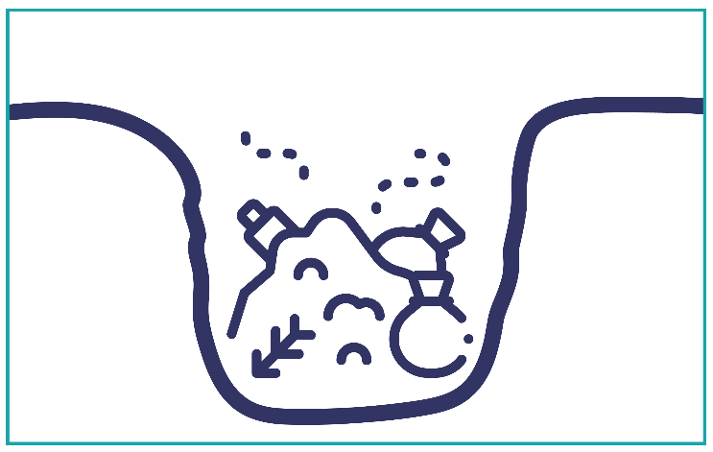

SEKSEN 3: Fasiliti Asesmen

Gudfala Standed long Fasiliti
Ministry blong Helt long Vanuatu oli wantem leftemap ol Heltkea Fasiliti long Vanuatu blong mitim wan gudfala standed we i nogat tumas Problem we hemi save kosem sikness mo kil long ol sikman, sikwoman mo staf we oli kam long Fasiliti.
Sapos Fasiliti i no mitim standed long wan pat, bae yumi save adem sam impruvmen long Seksen 4 blong leftemap standed blong Fasiliti ia.

Fasiliti Asesmen
Long seksen ia bae yumi wokbaot blong lukluk mo ansaren kwestin long ol difren pat blong Fasiliti we yumi deskribem finis. Bakegen hemi ol impoten topik:
- Wota | - Saniteisen |  |  | - Haejin |  | - Toti | - Kondisen |  |  | - Disasta
Long asesem bae yumi faenemaot ol Problem we i gat long Fasiliti, mo sam tingting long ol Impruven we yumi mas mekem blong lifemap Standed.
Risk Manejmen (Olsem wanem blong daonem saes blong Problem)
“Risk i stap taem we i gat wan Problem or samting we hemi save kosem sikness or kil”
Taem we yumi faenemaot wan Problem, yumi save disaed Problem ia hemi bigwan hamas? Yumi save tingbaot:  JANIS  - Wanem Janis samting no gud bae happen?  KONSEKWENS  - Sapos samting no gud i happen? Ol damej hem bae bigwan hamas? |  |  |  |  | 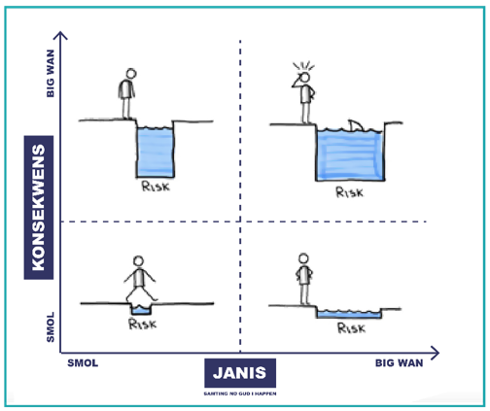
Afta yumi ansarem tufala kwestin ia, yumi stap kasem idia long wanem level blong Risk we i stap. Afta yumi save disaed long sam Impruvemen blong daonem level blong Risk.

Ol step we bae yumi folem blong ases ol topic blong WASH, Toti mo Kondisen blong Fasiliti hemi:
1. Lanem smol long evri topic. |  | à | 2. Lukluk mo reatem ol ansa blong asesmen. |  | à | 3. Faenemaot ol Problem long Fasiliti. |  | à | 4. Disaed long Impruvmen mo mekem praeoriti.

SEKSEN 3A: WOTA

Sos blong Wota
I gat fulap difren kaen sos blong Wota we yumi stap usum long Vanuatu. Ol difren kaen oli gat difren gudfala mo nogud saed blong hem long saed blong sefti. Nomoli i gat wan men sos, mo sam narawan we yumi stap usum taem we men sos i no gat.
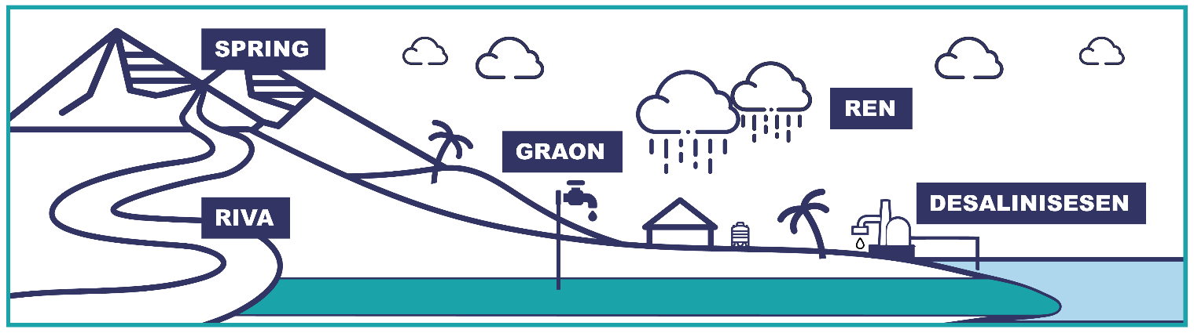

Ol yus blong Wota mo Deman
Gudfala wota hemi impoten tumas blong mekem ol difren kaen wok long wan Heltkea Fasiliti. Yumi mas save hamas wota i nidim long wan dei blong mekem ol wok long Fasiliti.
Deman – minim se hamas wota yumi stap yusum long wan dei or wan yia.

Sefti blong Wota
Traem tingbaot taem we wan drop blong wota hemi enterem Wol ia, sapos aot long ston or emi faldaon long sky. Tingbaot rod blong wota I mas folem kasem taem we yu leftem kap blong dring. Long rod ia, tingbaot eni samting we hemi save spoilem wota mo mekem i no sef blong dring.
Hemia nao ol wok blong Plan ia, faenemaot ol Risk, mo tekem Aksen blong daonem level blong Risk.
Spring bokis | Riva filta bokis |  | Borehole wetem Apron |  | Rain Fes Flas
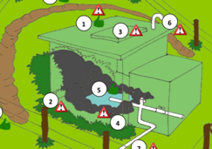 | 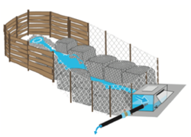 |  | 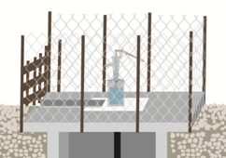 |  | 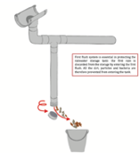
Hemi nao sam fasin blong protektem sam difren kaen sos blong Wota. Long seksen ia bae yumi wokbaot i go lukluk sos blong Fasiliti blong mekem asesmen long Sefti. Bae yumi yusum ol Risk Asesmen Kwestin we hemi stap long Tulkit Buklet blong jekem ol supplae mo paep blong sistem.
Mo tu bae yumi mekem sam Wota Kwaliti Tes blong jekem i gat eni bebet long wota we hemi kamaot long sitsit blong man or blong animol. Sapos sos hemi long we tumas, yu save mekem ol sefti asesmen long ples we hemi klosap mo. e.g. Tang.

Hamas Wota i gat?
Yumi wantem save se i gat inaf wota i kamaot long sos blong mitim hamas wota yumi nidim long Fasiliti. Suplae – minim se hamas wota sos hemi givim long wan dei or wan yia.
Yumi save mesarem hamas wota I kamaot long sos long wan dei or hamas i faldaon long wan ruf long wan yia yusum Flo-ret mo Renwota Kapja gaed long Toolkit Buklet. Afta yumi save lukluk wanem wan hemi bigwan, Suplae or Demand?
Gudfala ples blong mesarem flo-ret blong wota
Sapos Fasiliti i sarem tank wetem komuniti, mas inkludem olgeta long SUPLAE mo DEMAN kalkulesen.
Kamaot long Sos: mbae talema hamas wota hemi avelabol long ol yusa blong sistem.
Long tap long Fasiliti: hamas wota hemi avelabol long Fasiliti.
Ko insaed long Tang: hamas wota hemi avelabol long ol usa blong tang ia.

Wota Storej mo Sekuriti
Long Vanuatu i gat plante samting we hemi save spoilem sos mo storej blong wota, e.g., saeklon, draetaem. Yumi mas jekem i gat inaf storej blong holem wota sapos suplae i bagarap. Bae yumi kaontem hamas wota tang i gat mo ol tang hemi bigwan hamas? Sapos Suplae i no givim eni wota long tu dei, bae wota long tang hemi inaf blong mitim Deman blong Fasiliti?

Ples blong karem Wota – Tabs
Yumi mas gat ol Tab blong karem wota i stap klosap long ples blong wok. Hem bae helpem yumi gat gudfala haejin oltaem.
Samtaem ol Tab oli no wod gud tumas. Gud blong yumi save hamas i no wok mo hamas taem long wan wik yumi nogat wota i kasem Fasiliti.

Wota Storej insaed long Fasiliti
Las samting hemi blong lukluk long ol fasin blong storem wota insaed long Fasiliti. Taem we wota hemi aot Tab, yumi mas lukaotem gud blong kipim sef. Fasiliti i plante samting we hemi save spoilem wota. Sapos yumi mistem bae hemi save mekem man sik bakagen.

EKSASAES – Sevem Wota
Naoia, Fasiliteta bae mekem wan demonstresen long saed blong olsem wanem blong seven Wota blong mekem sua se hemi sef blong dring. Lukluk long Toolkit Buklet blong ol step blong:
- Olsem wanem blong yusum wan Haoshol Filta Baket.
- Olsem wanem adem meresin blong Wota.
SERAMIK KANDEL FILTA  Hemia nao wan kaen Filta we yu save pem long stoa mo hem mbae mekem ol wota hemi sef blong dring.  Afta yu bin putem ol pat tugeta, yu adem wota long baket long top, afta wota bae drip daon sloslo blong fulemap baket andanit.  Sapos yu nidim instraksen blong hem, i stap long Ministry of Lands website, long Department blong Wota Risos. |  |  |  | 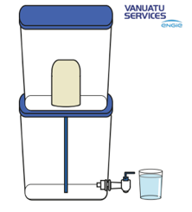
FOSET WOTA FILTA  Long kaen ia yu stap fulumap bakat wetem wota, afta hemi gat wan filta long foset.  Taem we yu wantem kapsaetem wota, yu lowerem tap ia, mo klin mo sef wota mbae kamaot. |  |  |  | 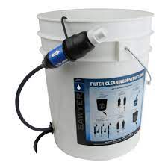

MERESIN BLONG WOTA
Olf meresin blong wota hemi fasin blong sevem wota usum usum smol tablet nomo. Ol tablet hemi gat wan meresin we hemi stap kilim ol bebet bifo yumi dring.

3A. ASESMEN blong WOTA (1 of 4)
- Sos blong Wota
- Wanem ol difren kaen wota yumi stap yusum long facility ia? Tickem ol we yu stap yusum.
 | 1 – Surfes |  |  |  |  | 2 – Spring |  |  |  |  |  |  |  |  |  | 3 – Renwota |  |  |  |  |  |  |  |  |  |  |  |  | 4 – Open Dag Wel
 | 5 – Han Pam |  |  |  |  | 6 – Borehol |  |  |  |  |  |  |  |  |  | 7 – Paep wota suplae |  |  |  |  |  |  |  |  |  |  |  |  | Nogat wota
 | Nara (pls eksplen):
- Ol yus blong Wota mo Deman
- Wanem ol difren yus blong wota long Fasiliti ia? Tickem ol we yu stap yusum.
 | In-pesen kea |  |  |  |  |  | Surgery |  |  |  |  |  |  |  |  |  | Materneti wod |  |  |  |  |  |  |  |  |  |  | Rerem kaekae
 | Swim |  |  |  |  |  | Toilet |  |  |  |  |  |  |  |  |  | Dring |  |  |  |  |  |  |  |  |  |  | Wasem han
 | Klinim fasiliti |  |  |  |  |  | Laundri |  |  |  |  |  |  |  |  |  | Other (explain):
- Wanem kaen tritmen i gat blong ol sos blong wota? Tickem ol we yu stap yusum.
 | Filta long sos |  |  |  |  |  |  | Meresin |  |  |  |  |  |  |  |  | UV Laet |  |  |  |  |  |  |  |  |  |  | Sola disinfeksen
 | Filta long fasiliti |  |  |  |  |  |  | Boilem |  |  |  |  |  |  |  |  | Nogat |  |  |  |  |  |  |  | Nara:
- Fasiliti ia, hemi stap serem supplae blong wota wetem komuniti? |  |  |  |  |  |  |  |  |  |  |  |  |  |  |  |  |  |  |  |  |  |  |  |  |  |  |  |  |  | Yes |  | No
Sapos ‘Yes’, faenemaot DEMAN blong komuniti we oli stap usum sem wota. |  |  |  |  |  |  |  |  |  |  |  |  |  |  |  |  |  |  |  |  |  |  |  |  |  |  |  |  | Komuniti Deman (Lita/person/day):
Populesen blong komuniti usa = |  |  |  |  |  |  |  |  |  |  |  |  |  |  | x |  |  |  |  | 50 Lita |  |  |  |  | 100 Lita |  |  |  | =
- Hamas i nidim blong ol yus long Fasiliti long wan dei?
Enterem hamas man maximam i save gat mo hamas wota wanwan i nidim long wan dei.
Kaen yusa: |  | Hamas maximam? |  |  |  |  |  |  |  |  | Lita long wan man long wan dei |  |  |  |  |  |  |  |  |  |  |  |  |  |  |  |  | Fasiliti Deman (L/p/d):
Out-patient: |  |  |  |  |  |  |  |  |  | x | 10 Lita |  |  |  |  |  |  |  |  |  |  |  |  |  |  |  |  | = |  |  |  |  | +
In-patient*: |  |  |  |  |  |  |  |  |  | x |  | 50 Lita |  |  |  |  |  |  |  |  |  | 100 Lita |  |  |  |  |  | = |  |  |  |  | +
Staf |  |  |  |  |  |  |  |  |  | x | 50 Lita |  |  |  |  |  |  |  |  |  |  |  |  |  |  |  |  | =
*Sapos Renwota sistem nomo, usum 50 L/d.  Sapos i gat paep wota suplae, usum 100 L/d. |  |  |  |  |  |  |  |  |  |  |  |  |  |  |  |  |  |  | Fasiliti Deman = (Lita/person/day)

3A. ASESMEN blong WOTA (2 of 4)
- Hamas Wota i gat?
LUKLUK LONG TULKIT PEJ 10 - 12
Yusum Flo-ret mo Renwota Kapja gaed long Toolkit Booklet blong fulumap tebol andanit.
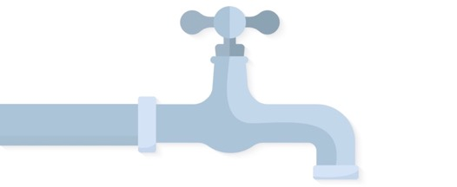
$Flo-ret \left(Lita per seken\right)=$

$$\frac{Volume (Lita)}{Taem (Seken)}$$

1 dei = 24 aoa x 60 minit x 60 seken = 86,400 seken
1 yia = 365 x 1 dei
- Hamas wota i kamaot long suplae blong men sos mo renwota?
Enterem ples we yu bin mesarem flo-ret mo konvertem i go Lita long wan dei mo wan yia.
 | < - Konvertem resal igo bitwin dei moa yia afta adem hamas i kamaot long Wota Suplae mo Renwota tugeta - >
Ples we yu bin mesarem flot-ret blong sistem: |  |  | Sos |  | Tang |  |  | Tap
Wota Suplae Sistem: |  |  |  |  | Lita/dei | x 365 =  = 365 ÷ |  |  |  | Lita/yia
Renwota Sistem: | + |  |  |  |  |  |  | +
TOTEL SUPLAE =

SUPLAE vs. DEMAN
- TOTEL SUPLAE (Q6.) blong wota hemi infa blong mitim TOTEL DEMAN (Q4. Komuniti Deman + Q5. Fasiliti Deman) long Fasiliti ia?
 |  |  |  |  |  |  |  |  |  |  |  |  |  |  | Yes |  |  |  |  |  |  |  |  |  |  |  |  | No
- Sefti blong Wota
LUKLUK LONG TULKIT PEJ 2 - 8
Long Tulkit buklet, faenem kaen sos blong wota we yu jusum finis (namba 1 – 7).
Ansarem ol Risk Asesmen Kwestin blong ol difren kaen sos we Fasiliti i stap usum.
Yu save wokbaot i go long sos blong mekem asesmen? |  |  |  |  |  |  |  |  |  |  |  |  |  |  |  |  |  |  |  |  |  |  |  |  |  |  |  |  |  |  | Yes |  |  |  |  |  |  |  |  | No |  |  |  |  |  |  | Sapos No, bae yu asses long storej.
3A. ASESMEN blong WOTA (3 of 4)
- Enterem ol Risk Sko mo level blong Risk (Hae tumas, Hae, Mediom, Lo) blong evri kaen sos blong wota.
 |  |  |  | Men sos |  |  |  |  |  |  |  |  |  |  |  |  |  | Seken sos |  |  |  |  |  |  |  |  |  |  |  |  |  |  |  |  |  |  |  |  |  |  |  |  |  |  |  |  | Paep wota suplae
Risk Skoa: |  |  |  |  |  |  |  |  | long: |  |  |  |  |  |  |  |  |  |  |  |  |  |  |  |  |  | long: |  |  |  |  |  |  |  |  |  |  |  |  |  |  |  |  |  |  |  |  |  |  |  | long:
Level blo Risk:
Long Tulkit Buklit, jusum gaed blong mekem wan Wota Kwaliti Test – (CBT Instruksen) blong mekem kwaliti tes ia.
LUKLUK LONG TULKIT PEJ 9 - 12
- Krosem ol namba blong bokis we hemi bin jenis i go blu long CBT Tes mo enterem level blong Risk.
 |  |  |  |  |  | Men sos |  |  |  |  |  |  |  |  |  |  |  |  |  |  |  |  |  | Seken sos |  |  |  |  |  |  |  |  |  |  |  |  |  |  |  |  |  |  | Paep wota suplae
Bokis I go blu: |  |  |  |  |  | 1 |  |  |  |  | 2 |  | 3 |  |  | 4 |  |  | 5 |  |  |  |  | 1 |  | 2 |  |  |  | 3 |  |  |  |  |  | 4 |  |  | 5 |  |  |  | 1 |  |  |  |  | 2 |  |  |  |  | 3 |  |  |  | 4 |  |  | 5
E.Coli (MPN/100ml)
Level blo Risk:
- Storej blong Wota
- Hamas Storej blong Wota i gat avelabol blong al sos blong wota?
- Enterem hamas tang i gat blong evri kaen sos mo total kapasiti mo hasmas % i stap naoia.
Source Type: |  |  |  |  |  |  |  | Men sos |  |  |  |  |  |  |  |  | Seken sos |  |  |  |  |  |  |  |  |  |  |  |  |  |  |  | Nara sos |  |  |  |  |  |  |  |  |  |  |  |  |  |  |  | TOTEL STOREJ
Hamas Tang: |  |  |  |  |  |  |  |  |  |  |  |  |  |  |  |  | + |  |  |  |  |  |  |  |  |  |  |  |  |  |  |  | + |  |  |  |  |  |  |  |  |  |  |  |  |  |  |  | =
Totel Storej (Lita): |  |  |  |  |  |  |  |  |  |  |  |  |  |  |  |  | + |  |  |  |  |  |  |  |  |  |  |  |  |  |  |  | + |  |  |  |  |  |  |  |  |  |  |  |  |  |  |  | =
Hamas % full naoia:
3A. ASESMEN blong WOTA (4 of 4)
- Sekiuriti blong Wota
- Men sos blong wota blong Fasiliti hemi go drae hamas taem long wan yia?
 |  |  | Neva drae |  |  |  |  |  |  |  |  | Wan taem nomo |  |  |  |  |  |  |  |  |  |  |  |  |  |  |  |  | Bitim wan |  |  |  |  |  |  |  |  |  |  |  |  |  |  |  | Hemi drae naoia
- Sapos ol sos blong wota oli fel, i gat inaf TOTEL STOREJ (Q9.) blong mitim TOTAL DEMAN (Q4.) blong tu dei? |  |  |  |  |  |  |  |  |  |  |  |  |  |  |  |  |  |  |  |  |  |  |  |  |  |  |  |  |  |  |  |  |  |  |  |  |  |  |  | Yes |  |  |  |  |  |  |  | 75% |  |  |  |  |  |  |  |  |  |  | No
- Fasiliti ia i gat wan plan blong protektem sistem blong wota taem long diasata? olsem Saeklon mo Draetaem? |  |  |  |  |  |  |  |  |  |  |  |  |  |  |  |  |  |  |  |  |  |  |  |  |  |  |  |  |  |  |  |  |  |  |  |  |  |  |  | Yes |  |  |  |  |  |  |  |  |  |  |  |  |  |  |  |  |  |  | No
- Ples blong karem Wota - Tabs
- Long Fasiliti ia, yu stap kolektem wota olsem wanem? Tickem wan
 | i gat paep mo tab insaed long bilding |  |  |  |  |  |  |  |  |  |  |  |  |  |  |  |  |  |  |  |  |  |  | wokboat long 2 minit kasem tab (~100 m)
 | wokboat 5 minit kasem tab (~500 m) |  |  |  |  |  |  |  |  |  |  |  |  |  |  |  |  |  |  |  |  |  |  | wokboat bitim 5 minit kasem tab (bitim ~500 m)
 | Kolektem surfes wota nomo |  |  |  |  |  |  |  |  |  |  |  |  |  |  |  |  |  |  |  |  |  |  | Nara (pls eksplen):
- Hamas taem long wan wik wota suplae long fasiliti hemi no inaf blong mekem ol wok?
 |  | I neva hapen |  |  |  |  |  |  |  | Evri wik |  |  |  |  |  |  |  |  |  |  |  |  | Evri dei |  |  |  |  |  |  |  |  |  |  |  |  |  |  |  |  |  | Nogat wota naoia
- Blong paep sistem, flo-ret blong wota hemi bitim 6L/min? |  |  |  |  |  |  |  |  |  |  |  |  |  |  |  |  |  |  |  |  |  |  |  |  |  |  |  |  |  |  |  |  |  |  |  |  |  |  |  | Yes |  |  |  |  |  |  |  |  |  |  |  |  |  |  | No
 |  |  |  |  |  |  |  |  |  |  |  |  |  |  |  |  |  |  |  |  |  |  |  |  |  |  |  |  |  |  |  |  |  |  |  |  | Wok gud |  |  |  |  |  |  |  |  |  |  |  |  | No wok
- Hamas ples blong karem wota i gat long Fasiliti mo hemi:
- Hamas ples blong swim i gat we hemi gat tab mo hemi:
- Storej blong wota long Fasiliti
- I gat ol klin kontena blong storem wota long fasiliti we kontena i gat lid long hem? |  |  |  |  |  |  |  |  |  |  |  |  |  |  |  |  |  |  |  |  |  |  |  |  |  |  |  |  |  |  |  | Yes |  |  |  |  |  |  |  |  |  |  |  | Sam i gat lid |  |  |  |  |  |  |  |  |  |  |  | No gat

SEKSEN 3B: SANITEISEN

Fasilisiti blong Saniteisen
Ol toilet mo sanitesen hemi no samting we yumi stap stori tumas long hem, be ol samting ia hemi impoten tumas blong helt blong komuniti mo evri woman mo man long Heltkea Fasiliti.

EXERCISE – The “F” Diakram
Naoia bae yumi mekem wan eksasaes we hem bae soem ol difren we ol sitsit blong man I save mekem yumi sik sapos yumi nogat inaf gudfala toilet long Fasiliti mo komuniti.
- Splitim Tim I go long grup blong 4 man mo karem flip chat pepa mo sam maka pen.
- Long lefhan saed long pepa, droem wan pikinini we hemi stap mekem sitsit long graon.
- Long raehan saed, droem wan plet blong kaekae.
- Stori long ol rod we ol bebet blong sitsit oli save tekem blong kasem kaekae. Droem laen mo arro long pepa blong soem ol posibol rod mo raetem nem blong hem.
- Stori long ol samting we yumi save mekem blong blokem ol rod blong bebet blong kasem kaekae. Droem ol blok long pepa mo raetem nem blong hem.
Droin ia yumi stap singaotem “F-Diakram” mo hemi soem from wanem hemi impoten tumas blong gat gudfala toilet blong blokem sitsit i muvmuv alboat long Finga, Flae, Fiel, Fluid kasem kaekae.
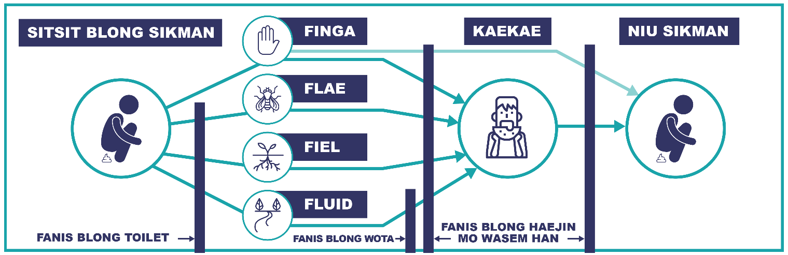

Ol difren kaen woman mo man: Blong mekem sua se ol woman mo man oli sef, hemi gud blong gat ol separet toilet blong staf mo sikman, mo blong man mo woman. Hemi impoten tumas blong gat toilet blong ol woman taem we oli gat sikmun. Blong ol pipol we oli gat disabiliti, yumi mas gat toilet we hemi bigwan lilbit (minimam 1.6m waed) more gat ol ba blong sapotem taem we wan i sitdaon mo gerap. Toetlet mas gat lok insaed mo aotsaed.

Saniteisen – taem blong Lukluk
I gat fulap samting blong jekem long sefti blong toilet, hemia difren long difren kaen toilet. Ol Risk Asesment Kwestin blong Saniteisen long Tulkit Buklet bae helpem yumi faenemaot ol problem long toilet. Wokboat i go long evri toilet, lukluk mo ansarem ol kwestin blong ol kaen we i stap.

3B. ASESMEN blong SANITEISEN (1 of 1)
- Fasiliti blong Sanitesen
- Hamas blong eij kaen toilet i gat long Fasiliti ia? No kaontem spos i bitim 30m aot long fasiliti.
Bus toilet: |  |  | Ventilated Improved Pit (VIP): |  |  |  |  | Por Flash: |  |  |  |  |  | Baten Flas:
Open Pit: |  |  | Kompos: |  |  |  |  | Nara:
- Eni long ol flas toilet oli gat Septik Tang? |  |  |  |  |  |  |  |  |  | Yes |  | Septik i no wok gud |  |  |  |  | No
- I gat difren toilet blong sikman mo sikwoman? |  |  |  |  |  |  |  |  |  | Yes |  | Yes, be nogat saen |  |  |  |  | No
- I gat difren tolet blong staf mo sikman? |  |  |  |  |  |  |  |  |  | Yes |  | Yes, be nogat saen |  |  |  |  | No
- I gat wan toilet blong woman mo gel wetem rabis bin mo tap long taem blong sikmun? |  |  |  |  |  |  |  |  |  | Yes |  | Yes, be toti/brok |  |  |  |  | No
- I gat wan toilet we hemi mitim standard blong akses blong pipol wetem disabiliti?  (miniman 1.6m waed) |  |  |  |  |  |  |  |  |  | Yes |  | Yes, be toti/brok |  |  |  |  | No
- Ol toilet oli gat ples blong wasem han wetem wota klosap long 3m? |  |  |  |  |  |  |  |  |  | Yes |  | Yes, be nogat sop |  |  |  |  | No
- Ol toilet oli stap long wan ples we i nogat naraman i save lukluk taem we wan i usum? |  |  |  |  |  |  |  |  |  | Yes |  | Sam, i no evri wan |  |  |  |  | No
- Ol toilet oli gat lok insaed blong sekiuriti? |  |  |  |  |  |  |  |  |  | Yes |  | Sam, i no evri wan |  |  |  |  | No
- I gat ol rekod blong klinim toilet? |  |  |  |  |  |  |  |  |  | Yes |  | Yes, be oli no fulumap |  |  |  |  | No
- Ol toelet hemi gat laet insaed long hem? |  |  |  |  |  |  |  |  |  | Yes |  | Sam, i no evri wan |  |  |  |  | No
- Risk Asesmen - Saniteisen |  |  |  |  |  |  |  |  |  |  |  | LUKLUK LONG TULKIT PEJ 17 - 19
- Komplitim wan Saniteisen Risk Asesment Form long evri toilet long Fasiliti, afta kaon hamas ‘No’ ansa i gat mo sapos yumi sud ‘Apgred’ or ‘Putum niu wan’.
Toilet #: |  | 1 |  | 2 | 3 | 4 |  |  | 5 |  |  | 6 |  |  | 7 | 8
Lokesen:
Hamas ‘No’ I gat:
‘Apgred’:
‘Putum Niu wan’:

SEKSEN 3C: HAEJIN

Ples blong Kea
Taem we yumi stap kea long ol sikman mo sikwoman hemi gat fulap janis blong pasem ol sik oa disis long han. Long fasiliti i mas gat gudfala haejin fasiliti blong mekem sua se ol staf mo sikman i save wasem han plante.
Ples blong Wasem Han  Yumi mas gat gudfala ples blong wasem han klosap long ol ples blong kea mo ol ples blong sakem toti. Minim se ol staf save wasem han hariap afta ol tajem samting no gud.  Gudfala ples blong wasem hand mas gat:  - Wota i save ron oltaem  - Hemi klin  - Sop i stap oltaem  - Alkol rab i stap blong disinfect.  Ol ples blong kolektem wota blong dring, mbae hemi no wan stret ples blong wasem hand olsem tap blong tang. | 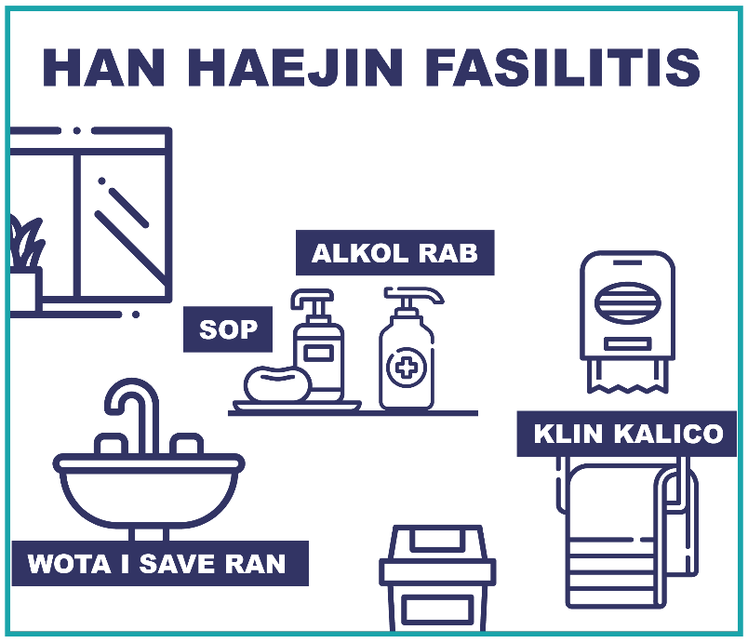

Haejin Promosen
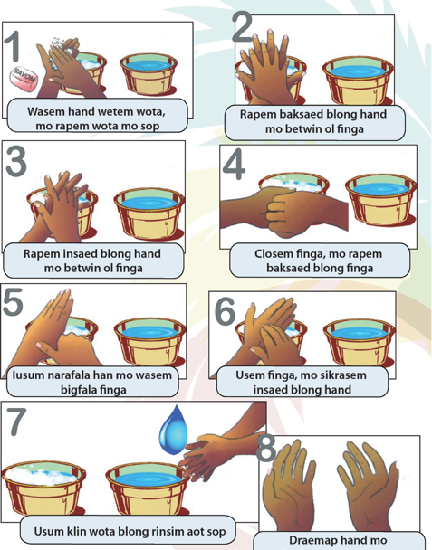 | Blong helpem komuniti mo ol staf blong folem gudfala fasin blong haejin, yumi sud gat ol posta i stap long wol blong Fasiliti. Eksampol posta hemi olsem wanem blong wasem han, olsem wanem blong kipim wota i sef, mo awenes long helti fasin blong ol woman long taem blong sikmun.
 | EKSASAES – Mekem Awenes
Wetem help blong vilej nes, mekem wan lis blong top trifala sikness we man i kasem fulap long komuniti ia. Sam eksampol:
- Skebies, sitsit wota, yaos, wom, konjankt.., etc.
Afta stori long wanem i mas jenis blong daonem ol sik ia. Raetem ol ansa long wan flip chat.
Mekem notis long komuniti, tim ia bae mekem wan toktok long komuniti blong talemaot ol tingting long eksasaes ia afta long nekis lanj. Mo tu bae yumi presentem ol risal blong Wota Kwaliti Tes.
3C. ASESMEN blong HAEJIN (1 of 1)
- Haejin long Fasiliti
- Ol ples blong givim kea hemi gat wan ples blong wasem han insaed long 3m? |  | Yes |  | Sam, be i no evri wan |  | No
- Ol ples blong wasem han i gat wota i save ron? |  | Yes |  | i no evri wan |  | No
- Evri ples blong wasem han i gat sop? |  | Yes |  | i no evri wan |  | No
- Ol ples blong sakem toti (aotsaed) i gat wan ples blong wasem hand i stap klosap? |  | Yes |  | i no evri wan |  | No
- I gat inaf posta blong soem gudfala fasin blong haejin i stap hang long wol? |  | Yes |  | Yes, be i no inaf |  | No
- Kaontem hamas i gat blong ol samting andanit. Bae helpem yumi disaed sapos ol fasiliti blong haejin hemi inaf or i no inaf.

Hamas i gat long Fasiliti ia? |  |  | Kaon: |  |  |  | Hamas totel:
- Ples blong givim kea |  |  |  |  |  |  | =
- Ples blong sakem toti (aotsaed) |  |  |  |  |  |  | =
- Toelet
- Ples blong wasem han |  |  |  |  |  |  | =
I gat inaf ples blong wasem han blong mitim hamas ples blong kea, wes desposel pit mo toelet i gat? |  |  |  |  |  | Yes |  |  |  | No
Long taem blong inspeksen ia, i gat hamas aot long ol ples blong wasem han we hemi:
- Nogat wota i save ron? |  |  |  |  |  |  | =
- Nogat sop i stap? |  |  |  |  |  |  | =
- Nogat gudfala dreinej blong karemaot wota? |  |  |  |  |  |  | =
- Hemi toti tumas? |  |  |  |  |  |  | =
Nomoli, hamas kes blong ol difren siknes bilo i gat long komuniti ia long wan manis?
Sitsit wota: | Skebis: | Yaos: |  | Konjanktivaetis: |  |  |  |  | Wom:

SEKSEN 3D: TOTI

Ples blong kolektem toti (insaed long Fasiliti)
I gat tri men difren kaen Toti long wan Heltkea Fasiliti. Sam kaen toti i save kosem kil bakegen sapos yumi no putem long stret ples. Fes samting hemi blong mekem sua se yumi gat difren tin blong kolektem ol difren kaen toti insaed long Fasiliti. Ol tin oli mas gat klia mak long hem blong soem wanem kaen toti i go insaed. Yu sud usum wan plastik insaed long Nomol Rabis nomo.
Tri difren kaen Toti we yumi sud gat separet kontena blong hemi:
Nomol Rabis |  | Infekses Toti |  | Sap Toti
Ol toti we I nomoli kamaot long wan haoshol: |  | Toti we hemi save infektem naraman mo woman: |  | Tul we hemi gat sap ej poin mo save kat mo stickem man mo woman:
 | - Pepa  - Kaekae  - Paket  - Bags |  | - Mask  - Glav  - Blad  - Fluid blo bodi |  |  | - Nidel  - Saringe  - Bled  - Naef

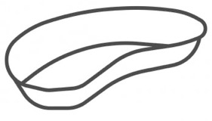
STERALISeSEN
Some ikwipmen yumi save usum bakagen sapos yu usum wan masine blong mekem steralisesen blong kilim ol bebet. Sapos fasiliti hemi stap mekem hemi, kolektem ol ikwipmen long wan dis mo kipim long wan sef ples bifo yu stap mekem steralisesen.

EKSASAES – Sotemaot Toti
Long eksaes ia bae yumi mekem praktis long separetem ol difren kaen toti we yumi gat long Heltkea Fasiliti:
- Splitem tim i go long trifala grup. Eaj grup bae mekem wan saen blong wan aot long ol tri kaen blong Toti.
- Stikem trifala pepa ia i go long wol.
- Fasiliteta bae kolemaot sam difren kaen Toti e.g. “Pepa” or “Mask”.
- Evri participen bae tekem turn blong disaed wanem korekt bin blong sakem kaen toti ia.
- Afta wan i disaed finis, hemi mas girap wokbaot i go tajem saen blong bin we toti sud go.
- Afta, ol nara memba blong tim disaed sapos oli akri.
Naja yumi sud save gud olsem wanem blong sotem ol toti long fasiliti.

SEKSEN 3D: TOTI

Tritmen blong Toti
Taem we yumi ‘Tritem Toti’, yumi stap tokbat wan proses we yumi destroiem infekses pat blong hemi blong mekem i mo sef blong usum bakagen oa sakem. Nomoli yumi mekem tritmen usum temperature we hemi hae tumas blong ol bebet mo hemi stap kilem olgeta ded. Afta yumi mas sakem long wan stret ples from sam blong ol sap samting bae stap yet.

STERALISESEN Usum AUTOCLAVE
Autoclave hemi wan masine blong hitim ol ikwipment we yumi wantem use bakagen. Hemi stap usum stim blong hitim ol ikqipment mo kilem ol bebet blong mekem hemi sef blong usum bakagen.

INCINERATOR  Incinerator yu save usum blong bonem ol infeskses mo sap toti blong mekem sua se hemi no moa infekses bifoa yu stap sakem. Afta long incinerasen mbae ol sap i stap yet, minim se yu mas sakem long wan ples we i nogat man i save kam long hem.  I gat ol difren kaen incinerator be sam I moa gud bitim narawan from oli no mekem tumas mok. Sapos hemi gat tu jemba hemi moa gud. |  |  |  |  | 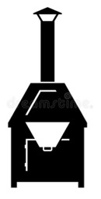

Bonem long wan open pit
Hemia wan veri besic fasin blong tritem toti, mo hemi no gud tumas from hemi stap kosem fulap smok, we hemi wan hazard long man mo environmen bakagen. Mo tu yumi no save sue se fiya ia hemi bin kilim ol bebet. Sapos yu stap mekem hemia, gudgud blong lukaotem wan rod blong pem wan incinerator long Fasiliti ia.

Ples blong sakem toti (aotsaed long Fasiliti)
Afta yu bin kolektem mo tritem ol toti, toti i sud go long wan ples we hemi sekua. Minim se ol komuniti, mo animol i no save go long hem mo no save tajem toti.
Wan gudfala ples blong sakem toti hemi:
- Gat lining long bottom long pit mo gat wan kava blong blokem animol, flae mo man i save tajem.
- Mas stap minimum 30 m aot long eni surfes wota, mo mas stap 50 m aot long eni sos blong wota.
- Mas gat fanis mo get blong blokem any memba blong komuniti mo animol i save kam insaed.
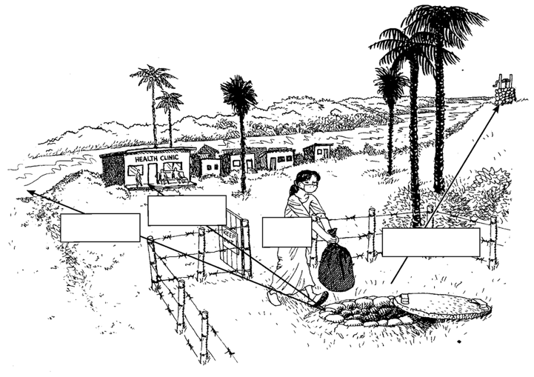
50 m
30 m
30 m
Gate
Skrew kap

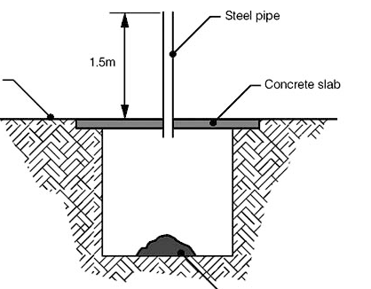
Blong blokem ol Toti
Steel oa PVC paep
I gat sam narafala fasin blong blokem eni animol mo man i save tajem ol infekses mo sap Toti.
1.5m antap long graon
Hemia nao wan eksampol long wan pit we oli mekem slap blong kavrem antap, afta putum wan paep it godaon blong sakem oli toti.
Hemia tu wan opsen blong ol Placenta afta long bon.
Konkrit slap
3D. ASESMEN blong TOTI (1 of 1)
- Ples blong kolektem toti
- I gat ples blong toti long evri ples we staf i stap tritem sikman mo sikwoman? |  |  |  |  |  |  |  | Yes |  | i no evri wan |  |  |  |  |  | No
- I gat tri difren ples blong toti; one blong: Haoshol toti, Infekses toti mo Sap toti? |  |  |  |  |  |  |  | Yes |  | i no evri wan |  |  |  |  |  | No
- Ol toti insaed long ples blong toti naoia hem luk olsem i stap long stret ples? |  |  |  |  |  |  |  | Yes |  | i no evri wan |  |  |  |  |  | No
- Ol tin blong toti oli gat lid i stap long top blong hem? |  |  |  |  |  |  |  | Yes |  | i no evri wan |  |  |  |  |  | No
- Ol tin blong toti oli gat inaf spes insaed? |  |  |  |  |  |  |  | Yes |  | i no evri wan |  |  |  |  |  | No
- Waste Disposal Fasiliti
- I gat hamas ples blong sakem medikol toti (infekses mo sap toti) long fasiliti ia? |  |  |  |  |  |  |  |  |  |  |  |  |  | =
- Wanem kaen tritmen blong toti oli stap usum long Fasiliti ia? Tikem ol we i gat
 | Autoclave masin |  |  | Incinerator |  |  | Bonem aotsaed |  |  |  |  |  | Nogat
- Ol medikol toti blong Fasiliti ia ol staf i stap sakem i go we? Tikem we oli mekem
 | Berem long wan pit |  |  |  | Sakem long open pit |  |  | Kolek mo karem i go long nara ples
 | Dampem wetem Nomol Rabis |  |  |  | Sakem long pit we i gat lining |  |  | Bokis blong Plasenta
 | Sakem long wan open ples nomo |  |  |  |  |  |  | Nara (eksplen):
- I gat wan fanis we I raonem ples blong toti? |  |  |  |  |  |  |  | Yes |  | Yes, be hemi no gud smol |  |  |  |  |  | No
- Ples blong sakem eni kaen toti i stap long we bitim 30 m aot long eni bilding? |  |  |  |  |  |  |  | Yes |  |  |  |  |  |  |  | No
- Ples blong sakem eni kaen toti i stap long we bitim 30 m aot long eni surfes wota? |  |  |  |  |  |  |  | Yes |  |  |  |  |  |  |  | No
- Ples blong eni kaen sakem toti i stap long we bitim 50 m aot long eni sos blong wota? |  |  |  |  |  |  |  | Yes |  |  |  |  |  |  |  | No
- I gat inaf powa (genereta) mo fuel blong tritem ol toti blong Fasiliti ia? |  |  |  |  |  |  |  | Yes |  | Samtaem i nogat inaf |  |  |  |  |  | No
- Ol staf oli bin gat sam trening long saed blong blong manejem toti? |  |  |  |  |  |  |  | Yes |  | Smol |  |  |  |  |  | No
- Staf oli gat ol protektiv ikwipmen? oslem glav, mask, mo glas, shus taem we oli sakem toti? |  |  |  |  |  |  |  | Yes |  | Yes, be i no inaf |  |  |  |  |  | No

SEKSEN 3E: KONDISEN BLONG FASILITI

General
Blong mekem ol staf mo ol komuniti oli no fraet blong kam long Heltkea Fasiliti ia, hemi impoten blong kipim bilding ia sekua mo klin.
Sam samting we hemi impruvem sekuriti hemi fanis, lok blong doa, mo i save gat laet blong mekem wok long naet sapos i nidim.

Cleanliness
Wan men samting blong kipim fasiliti klin hemi blong oganaes ol samting we i nidim blong mekem wok blong kin. Yumi no nidim tumas samting, be sapos i nogat ekipmen bae i hadwok.
Long seksen ia bae yumi lukluk long wanem level blong klenliness long Fasiliti ia, mo wanem equipmrent yumi nidim.

Proses
Wan proses hemi olsem wan lis we hemi talem ol difren step we bae yumi mekem sam wok. Gudfala proses i gat ol nem blong posisen blong staf we bae oli tekem risponsibiliti long evri step blong proses.  Wan kaen proses hemi wan rekon blong klinim Fasiliti. Hemi sud gat, taem, deit, mo nem blong staf we oli mekem.  Sam narafal process hemi ‘Infection Prevention Control’ mo olsem wanem blong usum ‘Personal Protective Equipment (PPE)’, hemi wan nem blong ol:  - Glav, protektiv klos, mask, protektiv glas  Ol samting ia hemi impoten tumas blong blokem infeksen i go long staf. |  | 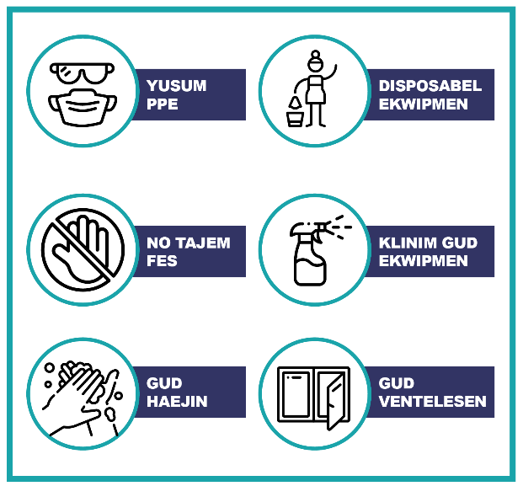

EKSASAES – Proses blong klin
Naoia bae yumi luk long wanem Proses we I stap blong klinem wan bed, mo sapos yumi save impruvem.
- Long grup diskas wanem proses we i stap naoia blong klinem wan bed blong sikman?
- Raetem ol namba blong step mo wanem wok blong eij step blong proses?
- Jusum wan voluntia we bae hemi mekem demonstresen blong proses we oli raetem.
- Afta, diskus proses ia i wok olstem wanem, mo wanem yumi save impruv?

SEKSEN 3E: KONDISEN BLONG FASILITI
Eksampol rekod blong proses

Rekod Blong Klin
- Disaed hu ia reponsibol blong kipim ol ples hemi klin
- Mekem wan niufala rekod blong evri manis
- Raetem ol ples blong klin long top
- Putum wan sirkol long bokis wan i mas klinim
- Afta wan i bin klinim, hemi raetem initials blong hem insaed long sirkol
Day # | Rum 1 |  | Rum 2 |  | Rum blong Wet |  |  | Toilet |  | … etc
1 | HR |  | HR
2 |  |  |  |  | HR |  |  | HR
3
4
5
6
… etc

INFENTORI
- Disaed long wan person we hemi inventori manaja
- Hemi risponsibol blong kipim trak long ol samting we hemi stap kam mo go long fasiliti
- Long en long evri manis hemi mas jekem ol namba blong ol samting i majem infentori.
ITEM NEM |  | KAEN |  | NAMBA |  | LOKESEN | EXPIRY DET |  | KONDISEN |  | PEM HAMAS?
Paket Sop |  | Klin |  | 4 |  | Laundri | Nogat |  | Gud
Sarinj |  | Medikol |  | 20 |  | Kabinet | 2024 |  | Gud
…
… etc.

3E. ASESMEN blong KONDISEN (1 of 1)
- General
- Bilding ia hemi sekua mo save lokem hem taem we hemi klos? |  | Yes |  | i no fulwan |  | No
- I gat wan fanis we hemi raonem Fasiliti mo get blong aksesem haos? |  | Yes |  | i no fulwan, or hemi brok |  | No
- I gat inaf laet mo powa long naet blong givim kea long naet? |  | Yes |  | i no oltaem |  | No
- Fasiliti hemi gat inklusiv akses blong ol pipol wetem disabiliti? |  | Yes |  | i igat ples we hemi save impruv |  | No
- Cleanliness
- Ol yad aotsaed long Fasiliti hemi klin mo nogat tumas toti i stap long graon? |  | Yes |  | Gat sam toti |  | No
- Ol flo blong Fasiliti oli klin mo long gudfala kondisen? |  | Yes |  | Sam, i no evriwan |  | No
- Ol tebol mo benj blong wok oli klin mo long wan gudfala kondisen? |  | Yes |  | Sam, i no evriwan |  | No
- I gat ol prodak mo tul blong klinim Fasiliti? (i.e. mop, baket, sop, etc.) |  | Yes |  | Sam, be no inaf |  | No
- Ol staf oli gat inaf glav mo narafala personal protektiv ikwipmen blong klin? |  | Yes |  | Sam, be no inaf |  | No
- I gat ol tul mo prodak blong wasem ol sikbed, sink, toilet, etc.? |  | Yes |  | Sam, be no inaf |  | No
- Proses
- I gat wan plan blong klin I stap, includem wanem taem, rekod mo risponsibiliti? |  | Yes |  | I gat, be staf i no usum |  | No
- Ol staf oli bin gat trening long ol proses blong klimin ol rum blong sikman? |  | Yes |  | Sam, be no inaf |  | No
- I gat inaf bed-net we oli tritem blong blokem mosquito? |  | Yes |  | Sam, be no inaf |  | No
- I gat wan proses mo inventory blong jekem ol personal protektiv ikwipmen? At lis tu taem long wan yia. |  | Yes |  | Sam, be no inaf |  | No

SEKSEN 3F: DISASTA

Pripea blong Disasta
Vanuatu i fesem fulap difren kaen disasta we hemi save hapen hariap, olsem wan Volkano, or hemi hapen sloslow, olsem longfala drae taem. Plante taem ol staf blong Heltkea Fasiliti oli feswan blong givhand long taem blong disasta. Minim se hemi impoten tu mas blong gat wan Disasta Plan.
Ol Helt woka sud wok wetem ‘Community Water Committee and Disaster and Climate Change Committee’ (CDCCC) blong developem Plan mo givim awenes long komuniti long saed blong disasta.

Drae taem
Taem we i nogat ren long wan longfala taem, hemi save kosem ol level blong wota long riva mo spring blong go daon. Sapos wan komuniti hemi usum renwota nomo, drae taem hemi wan bigfala problem long komuniti mo wok blong heltkea fasiliti. El Niño hemi wan kaen weta we hemi save kosem drae taem long Vanuatu, from i gat moa win mo ren.
Wan long ol mos impoten samting blong mekem long drae taem hemi blong konsevem wota.

Saeklon
Saeklon hemi stap kilim Vanuatu plante mo kosem bigfala damej. Wetem woning sistem bae yumi gat smol taem blong pripea mo daonem risk blong bigfala damej long sam impoten samting.
Saeklon hemi save spoilem paep, tang, fiting or kavremap sos blong wota wetem lanslaed mo tri we i faldaon.

Volkeno, Asis mo Etkwek
Plante aelan long Vanuatu oli kamaot long Volkeno mo oli stap faerap yet. Taem we oli faerap oli save kosem asis we hemi spoilem wota mo kaekae. Etkwek yumi harem plante mo wanwan i save kosem damej long bilding mo wota sistem.

Flad
Flad i stap hapen afta long ren we hemi strong mo longfala. Hemi stap hapen long ples we hemi stap daon or klosap long riva mo solwota. Wota blong flad hemi stap karem fulap toti long hem mo save spoilem sos blong wota sapos hemi flad tu.

Jenis blong Klaemet
Mos long ol kantri agri naoia, ol aktiviti blong human stap kosem klaemet blong wol blong go antap sloslo. Ol jenis ia I save kosem weta blong jenis, minim se hamas ren i stap faldaon, mo saes mo level blong saeklon mo flad. Yumi mas stap rere blong ol difren kaen disaster blong daonem risk blong damej.

3E. ASESMEN blong DISASTA (1 of 1)
- Drae taem
- Fasiliti ia i gat sos blong wota hem wan oa stap sarem wetem komuniti? |  |  | Yes |  |  |  | No
- Hemi posibol blong lokem wota tang we fasiliti i usum? |  |  | Yes |  | Lok hemi brokbrok |  | No
- Wota sistem ia i stap lik minim se wota hemi stap wes? |  |  | Yes |  | Smol nomo |  | No
- Flad
- Wota long sos hemi stap go toti long taem blong bigfala ren? |  |  | Yes |  | No tumas |  | No
- Wota storej tank hemi stap long ples we wota i save kasem hem long taem blong flad? |  |  | Yes |  | No tumas |  | No
- Wota i save ron igo insaed long pit blong toilet long taem blong flad? |  |  | Yes |  | No tumas |  | No
- Volkeno mo Etkwek
- Wota sos or ruf blong renwota hemi stap klosap long wan volkeno? |  |  | Yes |  | No klosap tumas |  | No
- Storej tang blong wota oli stap long graon oa semen bes we hemi flat mo strong? |  |  | Yes |  | Graon nomo |  | No
- Saeklon
- Daonpaep blong renwota koleksen i save karemaot long taem blong saeklon. |  |  | Yes |  | Yes, be i no isi tumas |  | No
- Ol wota tang hemi gat rop i stap holem fas long graon? |  |  | Yes |  | No strong tumas |  | No
- Fasiliti hemi gat wan sef ples blong lokem ol meresin long taem blong saeklon? |  |  | Yes |  | Yes, be nogat lok |  | No
- Fasiliti hemi gat we blong sevem wota long taem blong Emergency? E.g. Filta, meresin
- Klaemet
- Komuniti ia hemi gat wan Disasta mo Klaemet Jenis Komiti? |  |  | Yes |  | I no aktiv |  | No
- Komuniti i gat wan plan blong kosevem wota long drae taem. |  |  | Yes |  | Sam, be no inaf |  | No

SEKSEN 4: IMPRUVMEN PLAN

Olsem wanem blong mekem Impruvmen
Nao ia yumi gat sam tingting long wanem Standed we i stap long Fasiliti nao ia. Afta yumi save lukluk long ol Impruvmen blong daonem ol Problem mo Risk mo semtaem yumi stap leftemap Standed blong Fasiliti.
Blong mekem Impruvmen i mas gat gudfala infomesen long wanem Tul mo Materiel bae I nidim blong mekem ol wok. Sapos yumi mas pem sam samting blong mekem wok bae yumi mas putum Kos blong hem. Gud tu blong putum nem blong Hu bae mekem ol wok mo Deit blong finisim ol wok.
Sapos yumi gat everi samting ia bae yumi gat wan gudfala Plan we Mintristry Blong Helt save usum blong pem sam samting blong Impruvmen.

Lis blong ol materiel – olsem ‘Bill of Quantities” (BoQ)
Long Tulkit Buklet i gat sam lis blong ol samting we Heltkea Fasiliti i stap nidim plante taem. Ol lis we hemi stap hemi blong:  - VIP Toilet (usum lokol mo impoted materiel)  - Inclusiv toilet blok wetem Septik  - “Flat-Pack” Stil toilet  - Wet-pit / Por Flas Toilet  - Renwota Kleksen Gata mo Slab blong Tang  - Tap extensen blong 100m (25mm PE paep)  - Tulset blong wota impruvmen  Sapos yu faenemaot yu nidim wan blong ol samting long Impruvmen Plan blong yu, yu save raetem nem blong long bokis ‘Tul mo Material’ i nidim.  Mo tu i gat sam narafal ‘Bill of Quantities’ fom we yu save us blong fulumap ol materiel we i nidim. | 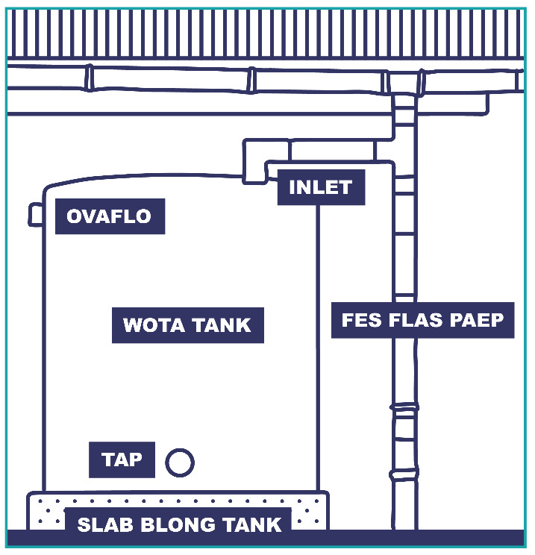  Renwota Klesen Gata mo Slab blo Tang  LUKLUK LONG TULKIT PEJ 21 - 27

Taem we yumi tingbaot Impruven, hemi gud blong disaed wanem oda bae yumi mekem ol wok. Ol Impruvmen we hemi isi mo jip yumi save mekem i hariap yusum man long komuniti nomo. Bae yumi putum 4 difren katagori long ol impruvmen depen DIFIKULTI BLONG MEKEM mo SAES BLON RISK:  - komiti mo komuniti save mekem mo hemi lo risk.  - komiti mo komuniti save mekem mo hemi hae risk.  - Mbae nidim sam givhan long Gavman oa ekspert mo hemi Lo Risk  - Mbae nidim sam givhan long Gavman oa ekspert mo hemi Hae Risk  Andanit i gat sam eksampol Impuvmen we oli fulumap finis. Sapos yu gat narafala Impruvmen blong mekem we i no stap long lis ia, tikem ‘Narawan’ mo raetem andanit. I gat sam empti bokis long en tu. |  |  |  |  |  |  | KATAGORI BLONG IMPRUVMEN |  | Saes blong Problem (Risk) hemi:
 |  |  |  |  |  |  | DifIkulti blong mekem Impruvmen |  | 3. HAD / SAS  LO RISK |  |  | 4. HAD / SAS  HAE RISK
 |  |  |  |  |  |  |  |  | 1. ISI / JIP  LO RISK |  |  | 2. ISI / JIP  HAE RISK
*STAT WETEM OL LO MO NO KOS OPSEN BLONG IMPRUVMENT!
Eria blong Impruv: | Impruvem i nidim: |  |  |  | Katagori (1-4): | Tul mo materiel I nidim |  |  |  | Kos | Hu bae mekem? |  | Deit blong finis?
I gat ples blong wasem han klosap long 10 m long evri toilet. | R | Mekem niu Han was |  |  |  | - Hammer  - Crobar  - Cement – 1 x 20 kg  - Poly pipe 25mm  - Poly adaptor 25mm |  |  |  | - 400 VT  - 600 VT  - 1000 VT  - 1000VT  - 1000VT  = 4000 VT | James – Community Plumber & |  | Complete by  30th May
 |  | Putum sop
 |  | Nogat |  | Narawan:
Sekuriti blong wota tang. | Mekem graon i flat mo mekem semen bes blong wota tang. |  |  |  |  | - Crowbar  - Shovel  - Cement – 4 x 40kg  - Timber – 4 x 200 x 50mm x 3m … etc. |  |  |  | - Free  - Free  - 4000 VT  - 3000 VT  Total = 10,000 VT | James – Community Plumber &  Julie - Treasurer of Health Committee |  | Complete by  15th July

4A. WOTA – IMPRUVMEN PLAN (1 of 4)
Folem ol Asesment Kwestin lukluk long ol Eria blong Impruvmen long Fasiliti, disaed long sam Impruvmen i nidim. Sapos yu gat narafala tingting long Impruvmen tickem ‘Narawan’ mo raetem bilo. Afta disaed long praeoriti blong hem mo ol samting i nidim blong mekem.
Eria blong Impruv: | Impruvem i nidim: |  |  |  | Katagori (1-4): | Tul mo materiel I nidim | Kos | Hu bae mekem? | Deit blong finis?
- SUPLAE mo DEMAN. |  | Faenem nara sos wota
 |  | Daonen hamas wota yumi usum
 |  | Nogat |  | Narawan:
- Daonen risk long sos. |  | Fiksimap sos blong daonen evri Risk.
 |  | Jenisim sos blo wota
 |  | Nogat |  | Narawan:
- Daonem risk long distribusen.. |  | Fiksimap paep suplae
 |  | Upgred paep suplae
 |  | Nogat |  | Narawan:
- Wota Kwaliti Risal. |  | Protektem sos
 |  | Fiksimap sistem
 |  | Boilem/sevem wota

4A. WOTA – IMPRUVMEN PLAN (2 of 4)
Eria blong Impruv: | Impruvem i nidim: |  |  |  | Katagori (1-4): | Tul mo materiel I nidim | Kos | Hu bae mekem? | Deit blong finis?
- Protektem sos i no go drae. |  | Planem tri long sos
 |  | Adem mo storej long sos
 |  | Nogat |  | Narawan:
- Inaf storej blong mitim Deman long 2 dei sapos suplae blong wota i fel. |  | Adem mo storej
 |  | Mekem Disasta Plan
 |  | Nogat |  | Narawan:
- Pripea blong Disasta |  | Mekem Plan
 |  | Tren staf mo komuniti long saed blog Disasta
 |  | Nogat |  | Narawan:
- Paep blong wota i kam insaed long fasiliti mo I gat tap blong kolektem wota. |  | Mekem wan niu Tab
 |  | Repair existing
 |  | Nogat |  | Narawan:

4A. WOTA – IMPRUVMEN PLAN (3 of 4)
Eria blong Impruv: | Impruvem i nidim: |  |  |  | Katagori (1-4): |  | Tul mo materiel I nidim |  | Kos | Hu bae mekem? | Deit blong finis?
- Insaed long Fasiliti wota i save ron oltaem. |  | Fiksimap sistem blong wota
 |  | Adem mo storej
 |  | Nogat |  | Narawan:
- Flo-ret blong wota long ol Tap oli bitim 6 Lita long wan minit (6 L/m). |  | Fiksimap ol lik
 |  | Upgrad wota sistem
 |  | Nogat |  | Narawan:
- Ol tap bong wota oli no stap lik. |  | Fiksimap ol Tab
 |  | Fiksimap ol lik long sistem
 |  | Nogat |  | Narawan:
- I gat inaf klin kontena blong storem wota blong dring. |  | Pem kontena
 |  | Mekem trening blong staf hao blong usum
 |  | Nogat |  | Narawan:
4A. WOTA – IMPRUVMEN PLAN (4 of 4)
Impruvem i nidim: |  |  |  |  | Katagori (1-4): |  | Tul mo materiel I nidim |  | Kos | Hu bae mekem? | Deit blong finis?
KAONTEM HAMAS IMPRUVMEN WE I GAT LONG EIJ DIREN KAEN KATAGORI: |  |  |  |  | 1 = |  | 3 =
 |  |  |  |  | 2 = |  | 4 =
4B. SANITEISEN – IMPRUVMEN PLAN (1 of 4)
Folem ol Asesment Kwestin lukluk long ol Eria blong Impruvmen long Fasiliti, disaed long sam Impruvmen i nidim. Sapos yu gat narafala tingting long Impruvmen tickem ‘Narawan’ mo raetem bilo. Afta disaed long praeoriti blong hem mo ol samting i nidim blong mekem.
Eria blong Impruv: | Impruvem i nidim: |  |  |  | Katagori (1-4): | Tul mo materiel I nidim | Kos | Hu bae mekem? | Deit blong finis?
- Fasiliti ia I gat inaf toilet. | Long kaen Fasiliti ia yumi sud:
 |  | Bildim mo toilet
 |  | Nogat |  | Narawan:
- Ol Flas toilet i gat wan gudfala septic tang. |  | Mekem niu septic tang
 |  | Fiksimap septic tang
 |  | Nogat |  | Narawan:
- I gat inaf difren toilet blong man mo woman. |  | Bildim narafal toilet
 |  | Adem saen (M/F)
 |  | Nogat |  | Narawan:
- I gat difren toilet blong staf mo sikman/sikwoman. |  | Bildim narafal toilet
 |  | Adem saen
 |  | Nogat |  | Narawan:

4B. SANITEISEN – IMPRUVMEN PLAN (2 of 4)
Eria blong Impruv: | Impruvem i nidim: |  |  |  | Katagori (1-4): | Tul mo materiel I nidim | Kos | Hu bae mekem? | Deit blong finis?
- I gat wan toilet we hemi gat rabis bin mo tap blong woman long sikmun. |  | Instolem tap insaed
 |  | Putum wan rabis bin
 |  | Nogat |  | Narawan:
- I gat wan toilet we hemi mitim standad blong akses blong pipol wetem disabiliti. |  | Bildim narafal toilet
 |  | Upgred wan we i stap
 |  | Narawan:
- I gat ples blong wasem han klosap long 10 m blong evri toilet. |  | Mekem Han Was stesen
 |  | Putum sop
 |  | Nogat |  | Narawan:
- Ol toilet oli givim praevisi. |  | Mekem wan skrin
 |  | Mekem niufala toilet
 |  | Nogat |  | Narawan:

4B. SANITEISEN – IMPRUVMEN PLAN (3 of 4)
Eria blong Impruv: | Impruvem i nidim: |  |  |  | Katagori (1-4): | Tul mo materiel I nidim | Kos | Hu bae mekem? | Deit blong finis?
- Ol toilet oli gat lok insaed. |  | Instolem lok
 |  | Ripea lok we i stap
 |  | Nogat |  | Narawan:
- Rekod blong klinem i stap we oli fulumap. |  | Mekem pepa blo rekod
 |  | Trenem staf blong komplitim
 |  | Narawan
- Daonem ol Risk long ol toilet. |  | Upgred toilet folem kwestin
 |  | Bildim niufala toilet
 |  | Nogat |  | Narawan

4B. SANITEISEN – IMPRUVMEN PLAN (4 of 4)
Impruvem i nidim: | Katagori (1-4): |  | Tul mo materiel I nidim |  | Kos | Hu bae mekem? | Deit blong finis?
KAONTEM HAMAS IMPRUVMEN WE I GAT LONG EIJ DIREN KAEN KATAGORI: | 1 = |  | 3 =
 | 2 = |  | 4 =

4C. HAEJIN – IMPRUVMEN PLAN (1 of 2)
Folem ol Asesment Kwestin lukluk long ol Eria blong Impruvmen long Fasiliti, disaed long sam Impruvmen i nidim. Sapos yu gat narafala tingting long Impruvmen tickem ‘Narawan’ mo raetem bilo. Afta disaed long praeoriti blong hem mo ol samting i nidim blong mekem.
Eria blong Impruv: | Impruvem i nidim: |  |  |  | Katagori (1-4): | Tul mo materiel I nidim | Kos | Hu bae mekem? | Deit blong finis?
- I gat inaf ples blong wasem han klosap long ol ples blong kea, toilet, mo ples blong toti. |  | Instolem niufala han was
 |  | Fiksimap han was we i stap
 |  | Nogat |  | Narawan:
- Ol ples blong wasem han oli gat wota i save ron. |  | Instolem niufala han was
 |  | Ripea han was we i stap
 |  | Nogat |  | Narawan:
- Ol posta blong haejin i stap long ples we yumi save lukim isi. |  | Hangem posta
 |  | Rikwes long Provins
 |  | Nogat |  | Narawan:
- I gat sop mo han sanetaesa long evri ples blong wasem han. |  | Pem sop
 |  | Pem sanetaesa
 |  | Nogat |  | Narawan:

4C. HAEJIN – IMPRUVMEN PLAN (2 of 2)
Impruvem i nidim: | Katagori (1-4): |  | Tul mo materiel I nidim |  | Kos | Hu bae mekem? | Deit blong finis?
KAONTEM HAMAS IMPRUVMEN WE I GAT LONG EIJ DIREN KAEN KATAGORI: | 1 = |  | 3 =
 | 2 = |  | 4 =

4D. TOTI – IMPRUVMEN PLAN (1 of 4)
Folem ol Asesment Kwestin lukluk long ol Eria blong Impruvmen long Fasiliti, disaed long sam Impruvmen i nidim. Sapos yu gat narafala tingting long Impruvmen tickem ‘Narawan’ mo raetem bilo. Afta disaed long praeoriti blong hem mo ol samting i nidim blong mekem.
Eria blong Impruv: | Impruvem i nidim: |  |  |  | Katagori (1-4): |  |  | Tul mo materiel I nidim |  | Kos | Hu bae mekem? | Deit blong finis?
- I gat ol ples blong toti i stap long ples blong tritem sikman mo sikwoman. |  | Instolem moa rabis bin
 |  | Fiksimap bin we i stap
 |  | Nogat |  | Narawan:
- I gat tri difren ples blong ol tri difren kaen toti mo oli gat saen? |  | Instolem moa rabis bin
 |  | Adem saen long bin
 |  | Nogat |  | Narawan:
- Oli difren kaen toti i stap go long stret ples? |  | Instolem saen
 |  | Mekem trenin blong staf
 |  | Nogat |  | Narawan:
- Ol tin blong toti oli gat lid blong blokem top blong hem? |  | Pem niu bin wetem kava
 |  | Replesem lid we i stap
 |  | Nogat |  | Narawan:
4D. TOTI – IMPRUVMEN PLAN (2 of 4)
Eria blong Impruv: | Impruvem i nidim: |  |  |  | Katagori (1-4): |  |  | Tul mo materiel I nidim |  | Kos | Hu bae mekem? | Deit blong finis?
- Ol ples blong toti oli no fulap tumas. |  | Mekem rosta blong klin
 |  | Mekem trening blong staf
 |  | Nogat |  | Narawan:
- Oli stap mekem sam kaen tritmen blong Medikol Toti bifo oli sakem. |  | Bildim wan Incinerator
 |  | Upgred pit we i stap
 |  | Nogat |  | Narawan:
- Ples blong sakem toti (aotsaed) i mitim standad we yumi wantem? |  | Upgredem ples blong toti
 |  | Mekem trening blong staf
 |  | Nogat |  | Narawan:
- Wan fanis i stap raonem ples blong sakem toti blong blokem akses. |  | Bildim fanis
 |  | Stat blong berem toti
 |  | Nogat |  | Narawan:
4D. TOTI – IMPRUVMEN PLAN (3 of 4)
Eria blong Impruv: | Impruvem i nidim: |  |  |  | Katagori (1-4): |  |  | Tul mo materiel I nidim |  | Kos | Hu bae mekem? | Deit blong finis?
- Ol ples blong sakem toti oli aot bitim 30 m long haos mo wota, mo 50m long wota sos. |  | Bildim niufala ples blong toti.
 |  | Movemaot haos long pit.
 |  | Nogat |  | Narawan:
- Inaf fuel i stap blong tritem ol infekses toti bifo oli sakem. |  | Jenisim fasin blong tritmen.
 |  | Rekwestem fand blong fuel.
 |  | Nogat |  | Narawan:
- Ol staf bin gat trening long olsem wanem blong wok wetem medikol toti. |  | Raetem proses
 |  | Mekem trening blong staf
 |  | Nogat |  | Narawan:
- Ol staf i gat inaf protektiv ikwipmen blong taem we oli holdem medikol toti. |  | Pem niufala ekipmen
 |  | Mekem trening blong staf
 |  | Nogat |  | Narawan:
4D. TOTI – IMPRUVMEN PLAN (4 of 4)
Impruvem i nidim: |  |  |  |  | Katagori (1-4): |  |  | Tul mo materiel I nidim |  | Kos | Hu bae mekem? | Deit blong finis?
KAONTEM HAMAS IMPRUVMEN WE I GAT LONG EIJ DIREN KAEN KATAGORI: |  |  |  |  | 1 = |  |  | 3 =
 |  |  |  |  | 2 = |  |  | 4 =

4E. KONDISEN BLONG FASILITI – IMPRUVMEN PLAN (1 of 4)
Folem ol Asesment Kwestin lukluk long ol Eria blong Impruvmen long Fasiliti, disaed long sam Impruvmen i nidim. Sapos yu gat narafala tingting long Impruvmen tickem ‘Narawan’ mo raetem bilo. Afta disaed long praeoriti blong hem mo ol samting i nidim blong mekem.
Eria blong Impruv: | Impruvem i nidim: |  |  |  | Katagori (1-4): | Tul mo materiel I nidim | Kos | Hu bae mekem? | Deit blong finis?
- Bilding ia hemi sekua mo save lokem hem long naet. |  | Instolem lok long doa
 |  | Ripea doa we hemi brok
 |  | Nogat |  | Narawan:
- Wan fanis I stap raonem fasiliti. |  | Bildim niu fanis
 |  | Ripea fanis we i stap
 |  | Nogat |  | Narawan:
- Inaf laet i save laet long naet blong mekem wok. |  | Upgred powa suplae mo laet
 |  | Instolem niufala laet
 |  | Nogat |  | Narawan:
- Ol graon raonem Fasiliti hemi klin mo klea. |  | Karemaot rabis
 |  | Klinim groan
 |  | Nogat |  | Narawan:

4E. KONDISEN BLONG FASILITI – IMPRUVMEN PLAN (2 of 4)
Eria blong Impruv: | Impruvem i nidim: |  |  |  | Katagori (1-4): |  | Tul mo materiel I nidim |  | Kos | Hu bae mekem? | Deit blong finis?
- Ol flo blong Fasilti oli klin mo sef. |  | Mekem shedul blong klin
 |  | Mekem trenin blong staf
 |  | Nogat |  | Narawan:
- Ol benj mo ples blong wok oli klin. |  | Mekem shedul blong klin
 |  | Mekem trenin blong staf
 |  | Nogat |  | Narawan:
- Ol tul blong klin i stap mo oli no brokbrok. |  | Pem niufala tul
 |  | Mekem inventori
 |  | Nogat |  | Narawan:
- Staf oli gat inaf protektiv ikwipmen mo i gat wan inventory blong hem. |  | Pem protektiv ikwipmen
 |  | Mekem inventori
 |  | Nogat |  | Narawan:
4E. KONDISEN BLONG FASILITI – IMPRUVMEN PLAN (3 of 4)
Eria blong Impruv: | Impruvem i nidim: |  |  |  | Katagori (1-4): |  | Tul mo materiel I nidim |  | Kos | Hu bae mekem? | Deit blong finis?
- I gat wan gudfala ples blong wasem klos mo sit blong bed. |  | Mekem ples blo laundry
 |  | Fiksimap laundry we i stap finis
 |  | Nogat |  | Narawan:
- Ol staf stap folem proses blong klin mo rekod long hem. |  | Raetem daon process
 |  | Mekem trening blong staf
 |  | Nogat |  | Narawan:
- Inaf bednet is stap blong blokem moskito. |  | Mekem oda blong net
 |  | Mekem inventori
 |  | Nogat |  | Narawan:
- Fasiliti hemi gat inklusiv akses blong ol pipol wetem disabiliti. |  | Bildem ramp akses
 |  | Put rel long wokwe
 |  | Nogat |  | Narawan:
4E. KONDISEN BLONG FASILITI – IMPRUVMEN PLAN (4 of 4)
Narafala Impruvem i nidim: |  |  |  |  | Katagori (1-4): |  | Tul mo materiel I nidim |  | Kos | Hu bae mekem? | Deit blong finis?
KAONTEM HAMAS IMPRUVMEN WE I GAT LONG EIJ DIREN KAEN KATAGORI: |  |  |  |  | 1 = |  | 3 =
 |  |  |  |  | 2 = |  | 4 =

4E. DISASTA – IMPRUVMEN PLAN (1 of 3)
Folem ol Asesment Kwestin lukluk long ol Eria blong Impruvmen long Fasiliti, disaed long sam Impruvmen i nidim. Sapos yu gat narafala tingting long Impruvmen tickem ‘Narawan’ mo raetem bilo. Afta disaed long praeoriti blong hem mo ol samting i nidim blong mekem.
Eria blong Impruv: | Impruvem i nidim: |  |  |  |  | Katagori (1-4): |  |  | Tul mo materiel I nidim |  |  | Kos | Hu bae mekem? | Deit blong finis?
- Fasiliti i gat tank blong wota blong hem wan. |  | Putum narafala tank
 |  | Komuniti aweness
 |  | Nogat |  | Narawan:
- Fasiliti is save lokem tang blong konsevem wota. |  | Adem lok long tang
 |  | Fiksimap lock we i stap
 |  | Nogat |  | Narawan:
- Sistem i no stap lik mo westem wota. |  | Fiksimap ol lik long paep
 |  | Pem niu fiting
 |  | Nogat |  | Narawan:
- Sos blong wota hemi gat proteksen long bigfala ren. |  | Sevem wota
 |  | Protektem sos
 |  | Nogat |  | Narawan:
- Wota Tank i no stap long ples blong flad. |  | Movem storej tang
 |  | Digem divesen ditch
 |  | Nogat |  | Narawan:
4E. DISASTA – IMPRUVMEN PLAN (2 of 3)
Folem ol Asesment Kwestin lukluk long ol Eria blong Impruvmen long Fasiliti, disaed long sam Impruvmen i nidim. Sapos yu gat narafala tingting long Impruvmen tickem ‘Narawan’ mo raetem bilo. Afta disaed long praeoriti blong hem mo ol samting i nidim blong mekem.
Eria blong Impruv: | Impruvem i nidim: |  |  |  |  | Katagori (1-4): |  |  | Tul mo materiel I nidim |  |  | Kos | Hu bae mekem? | Deit blong finis?
- Toilet oli no stap long ples flad. |  | Movemaot toilet
 |  | Digem divesen ditch
 |  | Nogat |  | Narawan:
- Wota sos mo ruf kajmen i oli no stap klosap long Volkeno. |  | Instolem fes flas
 |  | Bildem kava blong sos
 |  | Nogat |  | Narawan:
- Wota Tang i stap long flat mo strong graon. |  | Bildem bes blong tan
 |  | Levelem gud graon
 |  | Nogat |  | Narawan:
- Daonpaep blong Renwota I save kamaot long taem blong saeklon. |  | Instoel niu daonpaep
 |  | Fixem daonpaep
 |  | Nogat |  | Narawan:
- Komuniti gat wan CDCCC mo disasta rispons plan. |  | Rekwes wan trening
 |  | Holdem komuniti miting
 |  | Nogat |  | Narawan:
4E. DISASTA – IMPRUVMEN PLAN (3 of 3)
Narafala Impruvem i nidim: |  |  |  |  | Katagori (1-4): |  |  | Tul mo materiel I nidim |  |  | Kos |  | Hu bae mekem? | Deit blong finis?
KAONTEM HAMAS IMPRUVMEN WE I GAT LONG EIJ DIREN KAEN KATAGORI: |  |  |  |  | 1 = |  |  | 3 =
 |  |  |  |  | 2 = |  |  | 4 =

SECTION 5. JEKEMAP MO MENETENES
Blong mekem sua se ol wok long Fasiliti i save ron gud oltaem, hemi impoten yumi stap mekem regula jekap long men pat blong Fasiliti. Afta sapos yumi faenemaot samting i brokbrok or i no wok gud, yumi mas fiksimap, olsem yumi talem mentenens. Taem we yumi raetem daon wan Jeklis ol staf bae save wanem wok blong hem, mo wanem tul i nidim mo wanem taem blong mekem.
 |  | Jekemap  Wan nara nem blong mekem jekap hemi ‘Monitor’. Hemia minim wan proses yumi stap folem blong lukluk ol tul, aktiviti mo resos blong fasiliti blong jekem hemi stap wok or nogat.  Taem we yumi faenemaot samting i no gud, yumi save mekem plan mo aksen blong fiksimap.  Ol staf long Fasiliti i save givhan sapos oli talemaot ol samting we oli lukluk i no gud. |  |  |  |  |  |  | Fiksimap oa ‘Mentenes’  Mentenes hemi inlkludem ol aktiviti we yumi stap mekem oltaem blong mekem samting i stap wok gud.  Taem we yumi mekem jekap mo faenemaot samting i brok no gud, hemia nao taem blong mekem Mentenens mo fiksimap.  Blong mekem Mentenenes mas save se ol staf oli gat ol tul mo trening blong mekem wok ia. Komuniti plama i save givhan long ol samting blong fiksimap wota.
Topik | Pat blong Fasilit |  | Wanem blong mekem? |  | Wanem taem? |  |  | Tuls / Item i nidim? |  |  | Kos? |  | Hu bae mekem?
Saniteisen | Ol toilet blong staf mo sikman |  | - Jekem pepa i stap  - Replesem pepa sapos i nogat |  | Twaes long wan dei, moning mo aftanun |  |  | Rol blong toilet pep |  |  | 400VT long wan wik. |  | Klina
Toti | Ples blong sakem toti |  | - Jekem fanis i no brokbrok  - Fiksimap sapos hemi brok |  | Wan taem long wan wik. |  |  | Hama, nel, waea, waea kata, waea fanis. |  |  | 5000Vt long evri siks manis. |  | Klina, Vilej Plama

5. JEKEMAP MO FIKSIMAP
Blong evri Topik blong asesmen we yumi bin mekem (Wota, Saniteisen,etc.), disaed long ol aktiviti we I mas gat long Fasiliti ia. Afta putum ol narafala infomesen long pat blong Fasiliti mo hu mbae mekem, mo eni nara samting i nidim blong mekem ol aktiviti ia.
Topik | Pat blong Fasiliti |  | Wanem blong mekem? | Wanem taem? |  |  | Tuls / Item i nidim? |  |  | Kos? |  | Hu bae mekem?

5. JEKEMAP MO FIKSIMAP
Blong evri eria blong asesmen we yumi bin mekem (Wota, Saniteisen,etc.), disaed long ol aktiviti we I mas gat long Fasiliti ia. Afta putum ol narafala infomesen long pat blong Fasiliti mo hu mbae mekem, mo eni nara samting i nidim blong mekem ol aktiviti ia.
Topik | Pat blong Fasilit | Wanem blong mekem? | Wanem taem? | Tuls / Item i nidim? | Kos? | Hu bae mekem?

SECTION 6 – HELT KOMITI AKSEN
Blong kipim Plan ia ‘up to date’, I mas gat wan Helt Komiti we hemi aktiv. Ol wok blong Helt Komiti hemi blong mentenem Fasiliti, kolektem helt fi mo usum blong impruvment fasilit, lukaot long saniteisen, mo mekem sua se Komuniti i save kasem gudfala Heltkea.
Blong kipim komiti aktiv ia, yumi sud gat sam regula aktiviti we ol memba mo helt woka I mekem blong mekem sua se ol komuniti mo staf save komiti ia stap wok. Sam blong ol aksen hemi:

Rivyu blong WASH insaed Heltkea Fasiliti Plan
Komiti sud mekem wan rivyu blong WASH insaed HKF at lis wan taem long wan yia. Blong mekem rivyu yumi mas ansarem ol asesmen kwestin bakegen long evri topik blong WASH, Fasiliti mo Disasta blong lukluk wanem i jen.
Traem tingbaot, Fasiliti, komiti mo komuniti bin mekem sam jenis, or yumi stap semac nomo?

Holem Miting
Komiti ia sud gat sam miting truaot long yia blong luklukbak long progress we oli stap mekem aot long impruvmen plan, mo sapos ol fasiliti jekap mo mentenens i stak wok or nogat.
Hemi gud blong inkludum man mo woman aot long eni narafala komiti we i gat long komuniti, olsem Komiti blong Wota mo ‘Comuniti Disaster and Climate Change Committee’.

Fanresing
Mekem fanresing long komuniti hemi wan gudfala we blong mekem awenes long saed blong ol wok we Fasiliti i stap mekem mo ol komon sik we komuniti i stap fesem. Afta, ol fand we oli kolektem i save go long leftemap standad blong Fasiliti.

Trening
Yumi faenemaot finis long woksop ia i gat fulap samting blong manejem long wan Heltkea Fasiliti. Yumi no save lanem ol samting long wan tri dei woksop nomo, mas gat sam narafala trening long yia ia.
Helt Komiti i save mekem sam trening long komuniti long saed blong sefti blong wota mo gudfala haejin. Mo komiti i save askem long Provincial Helt Ofisa mo Komuniti Wota Developmen Ofisa blong mekem sam trening blong ol memba blong leftemap skil blong olgeta blong manejem Fasiliti.

SECTION 6 – HELT KOMITI AKSEN
Disaed long mo raetem ol aksen blong Helt Komiti blong mekem long saed blong trening or Riviu blong WASH insaed Heltkea Fasiliti Plan we Helt Komiti i mas mekem, oa eni narafala aksen i nidim.
Aktiviti | Wanem Taem? | Hu bae mekem? | Wanem i nidim?

HCF WASH PLAN EVALUATION FORM
Deit blong woksop:
Ples we trening i stap:
Nem blong Fasiliteita
Sapos yu Agri oa yu no Agri long ol stetmen andanit mbae yu tikem bokis we hemi stret wan:
Kwestin | Agri Bigwan | Agri | No save | No Agri | No Agri nating
- Ol topik were yumi kavremap hemi impoten long wok blong mi.
- Ol infomesen ia mo toktok mi save folem.
- Ol kwestin long template ia mi save andastandem.
- Ol ojektiv blong trening ia mifala bin kasem.
- Taem blong flatem ol samting blong trening hemi stret.
- Wanem pat yu bin laekem aot long ol trening ia?
- Wanem pat mifala i save impruvem?
- Eni samting long template dokumen ia we mifala mas jenisim?
- Eni narafala komen?
Tank yu tumas .

