Water, sanitation, hygiene, waste and electricity services in all health care facilities achieves essential quality health services

DRAFT Global Framework for Action (2024-2030)
DRAFT for EXTERNAL REVIEW
16 October 2023

This document serves to guide global and national efforts and key collaborative actions to deliver water, sanitation, hygiene, waste (WASH) and electricity services in all health care facilities. It focuses on WASH and electricity services and ought to be implemented within broader health and climate efforts, including those focused on low carbon and climate resilient health care facilities and systems, “fit for purpose hospitals”, and more broadly efforts which support primary health care and delivery of high-quality, universal, essential health care. The Global Framework for Action is rooted in evidence and recommendations articulated in the WHO/UNICEF 2023 Global Progress Report on Water, Sanitation, Hygiene, Waste and Electricity in Health Care Facilities. The political mechanism through which targets and action will be reviewed is a UN General Assembly Resolution on WASH and electricity in health care facilities.

At-a-glance summary
Foundational Elements
- Integration: Integrate WASH, waste and electricity services into health planning, programming, financing and monitoring at all levels
- Costed, resourced national plans and relevant implementation: Global partners to support development, resourcing and implementation of realistic, costed national roadmaps in line with broader SDG 3 acceleration and health financing and programming efforts
- Measurement & accountability: Regularly monitor, document and review progress in meeting targets at the local, national, regional and global level; where targets not met, increase political and technical action to accelerate efforts
- Health workforce: Develop and empower sufficient health workforce to deliver and maintain WASH, waste and electricity services, and practise good hygiene
- Climate resilient and low-carbon health care facilities: Strengthen policies, standards and interventions aligned with climate resilient, low-carbon and sustainable health care facilities and health systems
Tools to support implementation
- Eight practical steps for universal access to quality care
- Water and Sanitation for Health Facility Improvement Tool (WASH FIT 2.0)
- Global knowledge platform and country tracker (www.washinhcf.org)
- Future resources on climate resilience and sustainability, value/damage cost analysis, sustainable health care waste management
Mechanisms
- The co-coordinators of the Framework for Action will consist of WHO and UNICEF supported by a core group of partners including World Bank and WaterAid
- A Strategic Global Group – composed of key health, climate, financing, energy and WASH partners will provide strategic support, insights and high level inputs
- WHO/UNICEF Joint Monitoring Programming reporting on services under SDG 6 (2024, 2026, 2028, 2030); WHO/UNICEF to track progress on national actions and implementation of UNGA resolution (2025, 2028, 2030).

Background
In 2018 the UN Secretary General issued a Global Call to Action on Water, Sanitation, Hygiene and Waste (WASH) in health care facilities, noting the huge gaps in WASH services and urgent need to improve the situation. This was followed by a World Health Assembly resolution (WHA72.7) in 2019, which articulated clear actions for governments, including implementing the eight practical steps. In addition, at the Regional Level, the European Protocol on Water and Health has helped advance work on conducting situational analyses, setting and meeting national targets, and increasing leadership and investments on WASH in health care facilities.

In response, WHO and UNICEF established global monitoring and reporting through the Joint Monitoring Programme, developed guidance and implementation tools., established a strategic taskforce and created a platform for tracking country progress, sharing resources and promoting knowledge exchange. Global progress reports have been published in 2019, 2020 and 2023. Furthermore, in early 2023, WHO and partners published Energizing health: accelerating electricity access in health-care facilities, which provides a comprehensive update on the status of electricity access in health-care facilities and highlights key gaps and priority actions.

Why now? Criticality of WASH, waste and electricity services in health care facilities
This Global Framework for Action marks a new phase in the work. The global calls for action are rooted in the evidence of the dire health, social and economic consequences of poor WASH services in health care facilities. An estimated 8 million people die annually in 137 low- and middle-income countries from poor-quality care, resulting in US$6 trillion in losses. In addition, approximately 43% of global newborn deaths occur in sub-Saharan Africa, where only half of health care facilities have a water source on site and where only half of hospitals have access to reliable electricity. Increasing the availability of WASH and electricity can also improve access to good-quality healthcare and reduce the likelihood of dying in childbirth. Furthermore, WASH, waste and electricity services are critical levers for accelerating access to primary health care preparing for and responding to disease outbreaks (e.g. cholera, Ebola), and delivering health services in emergencies. The value of investments will only increase in the face of future pandemics, climate change and increasing geopolitical insecurity and conflict.

Investing in good WASH and electricity services makes financial sense and is affordable. The cost of investing in WASH services is, on average, US$ 0.60 per person per year or just 6% of current annual per capita government spending on health. However, maintaining services requires a dedicated budget, which is absent or insufficient for millions of facilities. Financing for WASH operation and maintenance costs is a small fraction of the costs that result from inaction.

Current situation: the state of WASH, waste and electricity in health care facilities
Measured against the global SDG 6 target, progress is far off track achieving universal access to basic services as well as higher level of services in those places where basic has been achieved. An estimated 1 in 5 health care facilities (22%) lack basic water services, affecting 1.7 billion people, including 857 million people globally who access health care facilities with no water at all. Hygiene services remain limited: half of health care facilities lack basic hygiene services with water and soap or alcohol-based hand-rub where patients receive care and at toilets. Similar gaps exist for sanitation and health care waste: 1 in 10 facilities have no toilets, and 1 in 4 do not practise waste segregation. In addition, about 1 billion people are served by health facilities that either lack access to electricity (433 million people) or have unreliable supply of electricity (478 million people). In Sub-Saharan Africa, at least 15 percent of health facilities remain completely unelectrified, and another 40 percent have only unreliable access to electricity (see Annex 1 for summary of WASH, waste and electricity services).

Aims, Audience and Activities
The overall vision is that all health care facilities have safe and sustainable WASH and electricity services in order to enable quality, essential care for all. To achieve this, this Framework has three aims:
- Provide common and collaborative platform for monitoring, accountability and increasing understanding of situation, challenges and effective strategies
- Increase leadership engagement through policy directives, integration with key health and climate initiatives and
- Increase effective and sustainable country and partner investments
- Accelerate implementation on the ground
The target audiences for this Framework include health leaders and programme managers at the global and national level, policy-makers, WASH and energy leaders and technical experts, development experts and investment banks, climate actors and experts and more generally, civil society. Figure 1 provides an overall schematic of these different stakeholders and the key intersection areas for this specific work.

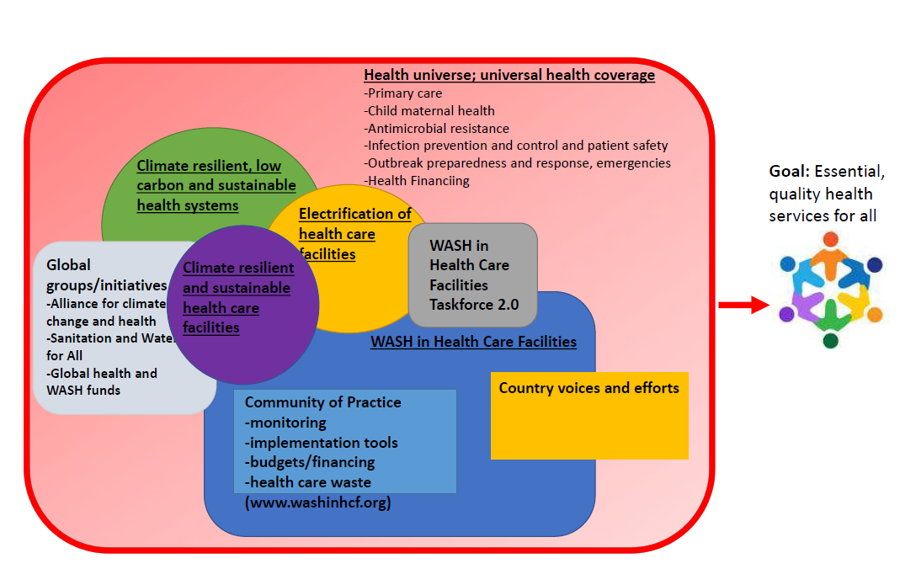

The activities by which success will be evaluated centre on five areas: national actions, service improvements, climate resilience and sustainability, health engagement and financing and investment (Table 1).
Table 1. Actions required –
Area | Action | Baseline (2020) | 2022 | Target 2026 | Target 2030
- National actions | 1.1 Establish baseline | 75% | 92% | -All countries have set baselines using harmonised global indicators | -All countries regularly update status of baseline (every 5 years)
 | 1.2 Update national WASH and waste standards | 52% | 53% | -All countries have standards which reflect latest evidence and address climate resilience, low-carbon and sustainable services/health care facilities. | -Updated standards are actively disseminated, implemented, regulated and monitored.
 | 1.3 Develop and implement costed roadmap | N/D | 63% | -All countries have developed and are working to resource and implement costed roadmaps with targets | -All countries are implementing costed roadmaps with regular, dedicated resourcing.
 | 1.4 Monitor WASH and electricity in health systems | 10% | 14% | -Half of countries have WASH, waste and electricity indicators in health monitoring information systems (HMIS) | -All countries regularly review and disseminate and use WASH, waste and electricity data in HMIS to inform policy and budgeting decisions.
 | 1.5 Secure sufficient financing of services | 11% | 12% | -Health care facilities in one third of countries have included regular and sufficient funding for WASH, waste and electricity; budget accountability supporting through regular monitoring and reporting | -Health care facilities in all countries have included regular and sufficient funding for WASH, waste and electricity; budget accountability supported through regular monitoring and reporting
2. Service Levels | 2.1 Increase services globally | Water: 76%  Sanitation: ND  Hand Hygiene: ND  Waste: ND  Electricity: ND | Water: 78%  Sanitation: ND  Hand Hygiene: 51%  Waste: ND  Electricity: 1 billion people served by health-care facilities with unreliable or no electricity | -All HIC and MIC have universal basic services and national standards and monitoring indicators exist for higher levels of service | -All HIC and MIC have universal basic and higher levels of service.  All health-care facilities have access to reliable electricity
 | 2.2 Increase services in least developed countries (LDCs) | Water: 50%  Sanitation: 37%  Hand Hygiene: ND  Waste: 30%  Electricity: ND | Water: 53%  Sanitation: 21%  Hand Hygiene: 32%  Waste: 34%  Electricity: ND | - 60% of health care facilities have basic services | -In LDCs, 100% of facilities have basic services and 50% have higher levels of service.  - All health-care facilities have access to reliable electricity
3.Climate resilience and sustainability | 3.1 Improve climate resilience and sustainability of services | ND | 83% countries have plans that address climate resilience of WASH and electricity technologies and systems in health care facilities | -100% of countries have plans that address climate resilience of WASH technologies and systems in health care facilities | -100% of countries have plans that address climate resilience of WASH and electricity technologies and systems in health care facilities and these plans are resourced and implemented
4. Health engagement | 4.1 Integrate into health policies, programming, and monitoring | -WASH and electricity indicators included in Quality of Care Standards for Mothers, Newborns and Children; | -WASH and electricity indicators and monitoring included in PHC framework, IPC Global Strategy, Quality of Care Strategies, health facility and workforce strategies | -WASH and electricity indicators and data included in monitoring of global health plans, including those on Patient Safety, Infection Prevention and Control, Pandemic Preparedness and Child/Maternal Health.  -50% of countries have WASH and electricity targets for health care facilities which are integrated into national health policies and monitoring  -All major health meetings will consider WASH and electricity services | -All countries regularly monitor WASH, waste and electricity services , and report on and budget for services within national health policies that aim to achieve UHC through a PHC-oriented approach
5. Financing and investment | 5.1 Increase regular and sustainable financing | Financing and budgets insufficient; no global data | Financing and budgets insufficient; no global data | -50% of countries have in place policies and mechanisms for the public, finance, WASH and electricity sector to prioritize capital investments and utility services to health care facilities and sets targets for expanding coverage. | -All countries have in place policies and mechanisms for public financing, WASH and electricity sector to prioritize capital investments and services to health care facilities and sets targets for expanding coverage.
ND: No data; HIC: high income country; MIC: middle income country; PHC: primary health care.

What needs to happen to achieve the aims

There are three broad areas where action is needed to achieve these goals: integration with health, regular monitoring and reporting and empowering and supporting the health workforce. Specific actions for each of these are detailed below.

- Integrate WASH and electricity services into health planning, programming, financing, implementing and monitoring at all levels
Integration of WASH, waste and electricity services into health planning, programming and financing is lacking and will require government leadership to drive change. Although WASH, waste and electricity standards and policies are increasingly included in key global health strategies and platforms (e.g. AMR, IPC, child and maternal health, primary health care), these elements are not sufficiently integrated into health systems monitoring, programming, budgeting and overall financing mechanisms. WASH, waste and electricity indicators, programming and budgeting should be incorporated in all phases of health efforts from planning through to implementation. With regards to financing, such services should be included in local facility budgets and expendixtures monitored.

Global
- All key stakeholders, in particular those focused on maternal and child health, primary health care, antimicrobial resistance and pandemic preparedness use and report on data on WASH, waste and electricity in health care facilities..
- Development partners and donors scale up funding and support to accelerate provision of WASH, waste and electricity services in all health-care facilities. All global health and WASH donors track and report on investments.
- Within health strategy and SDG 3 reviews, include WASH, waste and electricity data alongside other key tracer indicators and facilitate sharing of best practices and scalable solutions.
- All investments in services and infrastructure should include regular operation and maintenance and be climate resilient to ensure value for money and sustainability. Procurement of medicines, vaccines, diagnostics and PPE must include sustainable waste services as part of core funding and reporting.
- Advocate for greater investment and support of cost-effective solutions and influence leaders through major political forums (e.g. G7 group of nations, G20 group of nations, UN General Assembly, COP) and at global health events.

National and local level
- Encourage and incentivize strong cross-sectoral collaboration through intersectoral taskforces, joint sector reviews, and joint planning and funding.
- Establish and implement, according to national context, standards for safe, climate resilient and sustainable water, sanitation, hygiene, health care waste and infection prevention and control in all health care settings and incorporate standards into accreditation and regulation systems to strengthen accountability.
- Develop, resource and implement costed roadmaps with targets, in line with wider sector planning, working towards improving the climate resilience and sustainability of all services;
- Dramatically scale up national investments and create enabling frameworks to accelerate provision of WASH, waste and electricity services to all health-care facilities with
- Programme-wide costing estimates should be informed by overall fiscal constraints to determine a prioritized, sequenced and realistic financing plan at facility, subnational and national levels.
- Facilities and districts should ensure funding for WASH, waste and electricity-related services, including operation and maintenance, is included in operational funding plans and budgets are monitored for accountability.

- Regularly monitor and review progress, and strengthen accountability
Monitoring WASH, waste and electricity services should occur in all health care facilities on a regular basis to check on progress, maintenance of quality services and implementation of policies. Monitoring of WASH services should be integrated within health systems and key health programmes (e.g. patient safety, primary health care, child and maternal health, IPC, pandemic preparedness and emergencies) rather than remain as a stand-alone exercise. Data on services and national actions (“practical steps”) need to be regularly analysed and disseminated to enable review of progress at every level (facility, subnational, national, regional, global) and indicate where major gaps are.

Global
- Continue to increase data coverage through inclusion of global indicators in facility and programme surveys.
- Support countries to set higher levels of WASH, waste and electricity indicators (e.g. climate resilient and safely managed sanitation services and safe and sustainable water supplies).

National and local level
- Integrate harmonized WASH, waste and electricity indicators into national monitoring systems, and regularly collate, analyse, review and disseminate data findings at the national level.
- Regularly track and report on budgets and expenditure for WASH in health care facilities.
- Clearly assign accountability through policy and regulatory mechanisms for WASH infrastructure, operations and maintenance, and cleaning and waste.
- Compile and report on user and community input on WASH and electricity as part of wider quality of care improvement efforts.
- Adopt WASH, waste and electricity indicators in quality improvement plans and activities. Use risk-based improvement tools, such as WASH FIT, to sustain operation and maintenance, understand and plan for resource needs and track local progress.
- Develop and support structures to enable community members to articulate their needs and demands for quality health services, including provision of WASH, waste and electricity services.
- Incorporate civil society and community input into planning, budgeting and review processes.

- Develop and empower the health workforce to deliver and maintain WASH, waste and electricity services, and practise good hygiene
Finally, there is the need to build capacity of national and local authorities to secure sufficient human resources and expertise for integration of WASH across health programming. All individuals in the health workforce from facility managers to cleaners will benefit from greater understanding of the value of good WASH, waste and electricity services, implementable interventions, sustainability considerations and the resources and knowledge to improve services. Health care workers need not only safe and well-functioning infrastructure but also to be empowered to help improve the environments in which they work in a safe and sustainable way.

Global
- Develop WASH, waste and electricity curricula and training material that incorporate concepts of climate resilience, pandemic preparedness, emerging contaminants and risks, and sustainability that can be adapted to local contexts.
- Work to integrate these concepts into IPC and other major health curriculums (e.g., on child and maternal health, pandemic preparedness and response).
National and local
- Develop a cadre of WASH, waste and electricity staff through national training centres, and pre- and in-service curricula.
- Reduce, and sustainably and safely manage and treat waste to contribute to carbon reduction targets and climate commitments; link financing, as appropriate.
- Support all health care workers in good WASH and IPC practices by ensuring that have accessible and safe WASH, waste and electricity services and are adequately trained.
- Provide clear job descriptions and compensation, safe and healthy working environment for all workers, including cleaners and waste workers.
- Provide regular and ongoing pre-service and in-service training, mentoring and career development opportunities.
- Conduct regular training and mentoring on WASH and basic IPC, and integrate this with other relevant training (e.g. on safe childbirth, vaccinations, pandemic preparedness).

Who will make change happen: the case for greater cross-sectoral WASH, energy and health engagement

Leadership and coordination
WHO and UNICEF will continue to co-lead global efforts, supported by a group of core partners, including World Bank, WaterAid and others. In addition, global partnerships will be expanded to encourage greater collaboration with UN Water, other health agencies/funds such as GAVI and Global Fund and those working to promote electricity access and climate resilient and environmentally sustainable health care facilities. Furthermore, the 2023 UNGA Resolution provides a global mechanism for supporting and tracking country driven efforts.

Reporting
The WHO/UNICEF Joint Monitoring Programme will continue to provide reports every two years (2024, 2026, 2028, 2030) on the status of WASH and waste services. In this framework, WHO and UNICEF will also regularly report on the status of electricity in health care facilities in collaboration with relevant partners such as World Bank, building on and expanding the WHO database on electrification of health-care facilities. In addition, progress on national actions (the practical steps) as well as in-depth assessments of integration with key health programmes will be done by WHO and UNICEF regularly (2026, 2028, 2030). Critical to these efforts will be strengthened government engagement as well as collecting, validating and utilizing data on national actions and services.

Accelerating and scaling-up action: effective implementation of national plans.
WHO and UNICEF will, in cooperation with core global partners, including World Bank, support development, resourcing and implementation of costed national roadmaps and plans aligned with sector planning processes and fiscal constraints. Specific activities include:
- Development of guidance notes and tools to support costing and value/damage cost analysis, to inform roadmaps and make the “case” for greater investments
- Review of appropriate and affordable on-site technologies while, where possible, promoting improved and greater access to more sustainable and climate resilient, including well managed, centralized piped services
- Develop policy, regulatory and finance frameworks to support improved water,wastewater and electricity services,for improved service delivery
- Engage and influence emergency actors and funding to shift from procurement-based WASH, waste and electricity activities to climate resilient and environmentally sustainable systems incremental and more sustainable investments in human resources, technologies and the systems needed to maintain them.
- Provide country support to accelerate WASH and electricity services in health-care facilities

Resourcing plans: Ownership & accountability
The majority of the resourcing will need to come from the public sector including both national and local government and development partners. Private sector delivery capacity will need to be leveraged to complement public sector prioritization and recurrent financing.

Within the overall envelope of investments needed, a significant proportion is for regular operation and maintenance (along with support for good hygiene practices). Part of the effective and sustainable resourcing for these efforts will be the clear establishment of ownership of infrastructure assets (and corresponding operation and maintenance needs and responsibilities). For example, ministries of health are generally responsible for services within the facilities while the delivery of utilities to facilities is often managed by other sectors, including water, sanitation, energy and municipal governments.

In many LMICs, overall government budget envelopes are unlikely to increase significantly in the near term. In working to increase financial resourcing for WASH, waste and electricity in health care facilities there is a need to identify efficiencies and cost savings while also promoting and implementing the most cost-effective and climate resilient technologies and service delivery models. Donors and partners ought to support government systems and processes through catalytic funding, including in emergency situations. How this catalytic funding can be accessed, used and leveraged should be documented through case studies to support more effective use of resources.

Furthermore, the extent to which WHO and UNICEF as well as other key international actors are positioned to provide leadership and coordination, technical and financial support, and monitoring will depend on resources. To achieve the ambitious aims in this Framework an increase in resourcing is required at all levels, to and within countries and among supporting organizations.

Coordination and governance
Coordination of the Global Framework for Action will be co-led by WHO and UNICEF. Their efforts will be supported by a small group of core partners including World Bank and WaterAid, UNDP and US CDC. A wider group of organizations and NGOs will work to support advocacy, implementation and monitoring/reporting, especially at the national and sub-national level. These partners will work to implement specific elements of the Global Framework, strategically influence key health and other actors and report back on efforts. These roles will be specified as the work develops.

Effective implementation and strategic review of the Global Framework for Action will require dedicated, strategic leaders and thinkers who can regularly review progress and bring in ideas from other initiatives/sectors to identify and accelerate key successes and help focus on and unlock critical bottlenecks. Since 2021, the global work on WASH and waste in health care facilities has been overseen by the WASH in Health Care Facilities Taskforce. This Taskforce is officially concluding in September 2023. A new Taskforce 2.0 will be established with greater representation from health, energy, and climate communities along with key WASH entities (e.g. UN Water and Sanitation and Water for All) in order to work towards a more integrated, comprehensive, and strategic approach.

Annex 1: Global status of WASH, waste and electricity services
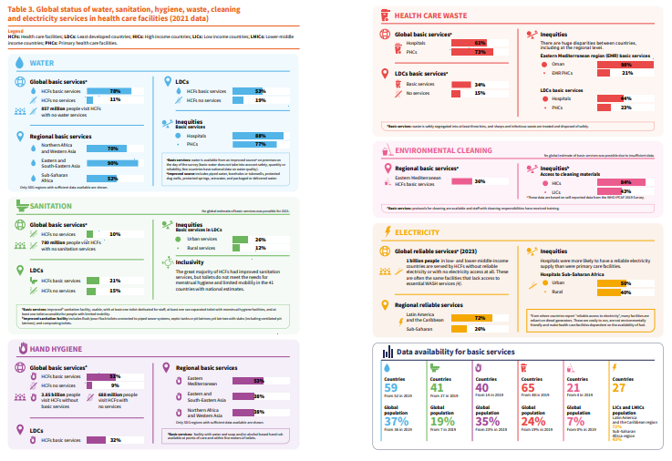

Annex 2: Implementation of Framework and Potential Partner Roles (to be discussed)

Capacity and skill building-proposed areas of focus
At the recent Global Summit on WASH, waste and electricity in health care facilities, attended by 120 health and WASH leaders from 35 countries, there was a strong call for more skill building and sharing among a community of practice. A number of focus areas were identified, and partners committed to facilitating discussions, knowledge products and activities. The following lists these areas which will be pursued based on partner interest and commitment. In addition, a number of trainings and webinars are planned to further explore, expand and share recent learnings and insights around these topics.

WASH FIT implementation, monitoring and outcomes/impact
(Co-led by Helvetas, UNICEF, WHO)
  - Discuss and document effect models of scale-up
  - Structure and document M&E (including costs, WASH improvements, outcomes (e.g. satisfaction of services, uptake of services, infections adverted, healthy births, etc)
  - Support use of electronic data collection and analysis (e.g. Kobo Toolbox)
  - Support to local government engineers to improve construction supervision and quality of WASH service improvements

Safe and sustainable health care waste
(Co-led by UNDP, WHO, UNICEF)
  - Support transition to safer and more sustainable waste management (e.g. waste reduction/optimal use of PPE, recycling, non-burn technologies)
  - Provide latest evidence and options for different settings on high temperature burn and non-burn technologies

Monitoring and review
(Co-led by WHO and UNICEF)
- Development of higher level service level indicators
- Case studies on how to integrate indicators within HMIS and use to inform policy review, reforms and resourcing

Costs, budgets and financing
(Co-led by World Bank, UNC)
  - Develop methodological note on national costing and damage cost analyses done in coordination with overall sector costing approaches
  - Document financing options, institutional arrangements, etc in different typologies of countries
  - Models for broader engagement with private sector, social enterprise, etc to invest in and maintain services

Policy and advocacy
(Co-led by WaterAid and )
  - Develop key speaking points/advocacy briefs for use at global political, health and WASH events
  - Conduct and disseminate findings from political economy/analyses at national/sub-national level for engaging leaders, increasing investments, etc

Annex 3: Tracking national actions “Country Tracker”

The current country tracker has been an important tool for assessing country progress in implementing the practical steps and WHA resolution. It will continue to serve an important accountability role as well as gauge of readiness for investors under the UNGA resolution. The tool is currently “low-tech” and meant to provide a rapid, a verified (including through supporting documents) assessment of progress.

To make use of limited resources this will continue. However, several improvements are needed and include:
- Revise criteria for indicators to support more objective assessment of progress
- Uncouple complex indicators (e.g. have more of a checklist)
- Better coordinate with partners country response and review
- Work with UN GLAAS to have better complementarity (e.g. focus on WASH sector investments to extend services to HCF) and alignment
- Publicly display more progress rather than static points in time

WHO/UNICEF, 2023. Global Progress Report on Water, Sanitation, Hygiene, Waste and Electricity in Health Care Facilities. https://www.who.int/publications/i/item/9789240075085
The UNGA resolution is being led by the UN Group of Friends for WASH in health care facilities. It is under consultation with probable approval/endorsement Q4 2023/Q1 2024.
The practical steps are: conduct situational analysis and assessment, set targets and define roadmap, establish national standards, improve and maintain infrastructure, monitor and review data, develop health workforce, and conduct operational monitoring. WHO/UNICEF, 2019. https://www.who.int/publications/i/item/9789241515511
WHO/UNICEF JMP provides official data and reporting to track progress on SDG 6 (safe water and sanitation) in households, schools and health care facilities. All data and reports can be found here: https://washdata.org/data/healthcare#!/
The Water and Sanitation for Health Facility Improvement Tool (WASH FIT), which focuses on WASH but also includes elements of electricity and climate resilience has been used in over 70 countries to help plan, cost and implement better WASH services. The latest WASH FIT V 2.0 was published in 2022 https://www.who.int/publications/i/item/9789240043237. In addition, the WHO/UNICEF WASH FIT portal includes training slides, fact sheets, training manual, etc: https://www.washinhcf.org/wash-fit/
The WHO/UNICEF knowledge platform is available to all interested stakeholders and includes information on country progress (country tracker), the WASH FIT training package and implementation tools and over 500 regional and country resources (e.g. standards, training reports, roadmaps, etc). www.washinhcf.org
Kruk ME, Gage AD, Arsenault C, Jordan K, Leslie HH, Roder-DeWan S, et al. High-quality health systems in the Sustainable Development Goals era: a time for revolution. Lancet Glob Health. 2018;6:e1196–252. doi:10.1016/S2214-109X(18)30386-3.
Fact sheet: newborn mortality. Geneva: World Health Organization; 2022 (https://www.who.int/news-room/fact-sheets/detail/levels-and-trends-in-child-mortality-report-2021). Neonatal mortality rate (0 to 27 days) per 1000 live births (SDG 3.2.2). Global Health Observatory [database]. Geneva: World Health Organization (https://www.who.int/data/gho/data/indicators/indicator-details/GHO/neonatal-mortality-rate-(per-1000-live-births).
GVEP International 2013
WHO/UNICEF, 2020. Operational framework for primary care. https://www.who.int/publications/i/item/9789240017832
Chaitkin M, McCormick S, Alvarez-Sala Torreano J, Amongin I, Gaya S, Hanssen ON, et al. Estimating the cost of achieving basic water, sanitation, hygiene and waste management services in public health care facilities in the 46 UN designated least-developed countries. Lancet Glob Health. 2022;10(6):E840–9. doi:10.1016/S2214-109X(22)00099-7.
Progress on WASH in health care facilities 2000–2021: special focus on WASH and infection prevention and control (IPC). Geneva: World Health Organization, United Nations Children’s Fund; 2023 (https://apps.who.int/iris/handle/10665/366657)
These figures refer to four developing regions: Latin America and the Caribbean, the Middle East and North Africa, South Asia, and Sub-Saharan Africa.
The outputs build on the global targets and metrics developed in 2018 in response to the UN Secretary General’s Call to Action on WASH in health care facilities. The latest progress against these is summarized in the WHO/UNICEF 2023 Global Progress Report on WASH in Healthcare Facilities. A more realistic target for achieving basic services in all HCF is proposed, given that the world is far off the initial target to reach 80% by 2022, when only 30% of facilities had basic waste services and only 37% had basic hygiene services.
This reflects percentage of countries that have finalized and are disseminating updated standards. Nearly 100% are currently working to update standards currently.
Climate resilient and sustainable standards address items such as reducing water wastage/conversation, use of renewable energy, reducing waste and procuring items with less and more eco-friendly packaging, etc.
This refers to the percentage of countries that have integrated indicators and are using them. An additional 21% (35% in total) have integrated indicators but monitoring systems are not yet functional.
All service levels refer to “basic service” as defined by the WHO/UNICEF Joint Monitoring Programme. In many cases such levels are below WHO basic standards (e.g. the water indicator does not consider water quantity, quality or reliability) and thus actual coverage is likely lower. For details on definitions refer to: https://washdata.org/sites/default/files/documents/reports/2019-04/JMP-2018-core-questions-for-monitoring-WinHCF.pdf
This is based on indicator A5 II from the WHO-led Global Analysis of Drinking-water and Sanitation (GLAAS). https://www.who.int/publications/i/item/9789240065031. This figure is based on only 40 countries responding so they may be a bias in the answer.
These three areas were highlighted and identified, based on the evidence and country progress, in the 2023 WHO/UNICEF Global Progress Report on WASH and electricity in health care facilities.
UN Member States who are engaged in the UN Friends of WASH in Health Care Facilities Group have set forth a proposal for a UN General Assembly Resolution on WASH, waste and electricity in health care facilities. The proposal and resolution will be discussed in Q3 2023 with approval/voting intended for Q4 2023.
Database on electrification of health-care facilities. Electrification of health-care facilities (who.int)
An analysis of the additional resources needed to implement this Framework will be conducted to support efforts in increasing catalytic funding and the accelerated effort needed to achieve stated objectives.
To learn more about the Global WASH in Health Care Facility Taskforce and key outputs please visit: https://www.washinhcf.org/governance/
A draft Concept Note for the Taskforce 2.0 has been developed and will be refined because of input from the current Taskforce and other key stakeholders. Taskforce 2.0 will be launched in 2024.
WHO/UNICEF Global Summit on WASH and electricity in health care facilities meeting report. June 2023. https://www.washinhcf.org/resource/global-summit-meeting-report-amman-jordan/
Information is gathered through excel, scoring is conducted by WHO/UNICEF and then verified by countries and then results are updated/put online on the country tracker. https://www.washinhcf.org/country-progress-tracker/. More information on the methodology for collecting information and criteria can be found in Annex 2 and Annex 3 of the 2023 Global Progress Report: https://www.who.int/publications/i/item/9789240075085

